

From Landscape to Lab: Utilization of Green Leafy Agricultural Biomass as a Source of Plant Proteins and Polyphenols.

Refining Proteins and Extracting Polyphenols with the Help of Polymeric Resins.

Olga Gladchuk

Independent project in Food Studies • 30 credits

Swedish University of Agricultural Sciences, SLU

Faculty of Landscape Architecture, Horticulture and Crop Production Sciences

Department of Landscape Architecture, Planning and Management

Food and Landscape Master’s programme

From Landscape to Lab: Utilization of Green Leafy Agricultural Biomass as a Source of Plant Proteins and Polyphenols.

Refining Proteins and Extracting Polyphenols with the Help of Polymeric Resins.

Olga Gladchuk

Supervisor: Anna-Lovisa Nynäs, Department of Plant Breeding, Swedish University of Agricultural Sciences (SLU)

**Assistant supervisor:**  Anna Peterson, Department of Landscape Architecture, Planning and Management, Swedish University of Agricultural Sciences (SLU)

**Examiner:** Faraz Muneer, Department of Plant Breeding, Swedish University of Agricultural Sciences (SLU)

Matilda Alfengård, Department of Landscape Architecture, Planning and Management, Swedish University of Agricultural Sciences (SLU)

**Credits:**  30 credits

**Level:** Master’s level (A2E)

**Course title:** Independent project in Food studies

**Course code:** EX1009

**Programme/education:** Food and Landscape Master’s programme

**Course coordinating dept:** Department of Landscape Architecture, Planning and Management

**Place of publication:** Alnarp

**Year of publication:** 2024

**Cover picture:** Gladchuk, O. (2024). *Lucerne juice with different resins.*

**Copyright:** All featured images are used with permission from the copyright owner.

**Keywords:** Foodscapes, green leafy agricultural biomass, landscape perspective, lucerne, plant-based protein, polymeric resins, polyphenols, polyphenol extractions, protein content, protein degradation, RuBisCO, sugar beet.

Swedish University of Agricultural Sciences

Faculty of Landscape Architecture, Horticulture and Crop Production Sciences

Department of Landscape Architecture, Planning and Management

Foreword

Dear reader, this research is my master’s thesis for the Food and Landscape program at the Swedish University of Agricultural Sciences, a cross-disciplinary program combining three spheres: people, landscape, and food. In search of a project that would allow me to cover all these areas, I got the opportunity to work with plant proteins within Plant Product Quality group at the Plant Breeding department. The chosen topic of my research is dedicating to the purification of plant-based protein derived from green agricultural biomass, as well as the extraction of polyphenolic compounds, which hold significant importance in the food, pharmaceutical, and cosmetic industries.

Motivated by its relevance to my studies, I selected this topic as it aligns with my interests and can serve as a foundation for further research, which I may pursue after defending my thesis. Although it diverges from the typical case studies or deeper theoretical research often seen in my program, it is directly related to the food studies, agriculture, and landscapes, because its inputs are plant agricultural side streams, while outputs are pure plant proteins and polyphenols commonly used in the food industry.

Within this thesis, you will read about a survey on the prospects of using agriculture green biomass and plant-proteins, along with discussions about different aspects of their production, such as meeting global food demand. Besides that, half of the work is an experimental pilot project, illustrating how innovative approaches can impact the production of plant proteins and contribute to more sustainable products. Of course, this part contains a detailed description of the methods and processes of the experiments, which may appear intricate to someone without experience in this field. However, this level of detail is necessary for future research that may build upon this work, and its inclusion is essential. In this case, I suggest not delving into the specifics of experiments but rather focusing on their conclusions.

I hope that this work will spark your interest in the topic of utilizing green agricultural biomass and plant proteins and motivates you to learn more.

Olga Gladchuk,

Alnarp,

April 2024

Abstract

The question of food system sustainability and the search for sustainable protein sources is a central theme in many research studies and discussions, where green leafy agricultural biomass represents an underutilized source of proteins. Additionally, this biomass contains polyphenols, which are known for their antimicrobial, anti-inflammatory, and antioxidant properties. This study, serving as a pilot project for subsequent larger research, delves into the extraction and subsequent recovery of polyphenols from green leafy biomass using diverse polymer resins. The project focuses on two purposes: to purify proteins from polyphenolic compounds, which can cause a bitter or astringent taste, and to extract polyphenols, which can then be utilized as a separate product in the food, cosmetic, and pharmaceutical sectors. All tests were conducted on two types of green juice derived from lucerne and sugar beet leaves. Findings reveal successful polyphenols extraction using various polymer resins, as confirmed by Folin-C and HPLC analysis. However, a decline in protein content, as indicated by SDS and BCA tests, hints at underlying factors such as alterations in protein solubility due to polyphenol extraction, resin-solution interactions, and effect of storage conditions. The results of the recovery process show a high percentage of extracted polyphenols, enabling their further utilization. Simultaneously with this work, a survey was conducted among researchers, producers, and individuals involved in work with plant-based protein. This survey aimed to provide information about potential interest in plant-based proteins and perceptions associated with them. The survey results indicate interest in such products, as well as participants' awareness of the benefits of plant-based proteins. However, number of participants wasn’t representative and preliminary conclusions require more thorough research.

*Keywords*: foodscapes, green leafy agricultural biomass, landscape perspective, lucerne, plant-based protein, polymeric resins, polyphenols, polyphenols extractions, protein content, protein degradation, RuBisCO, sugar beet.

Table of contents

List of tables 7

List of figures 8

Abbreviations 10

1. Introduction 11

1.1 Contextual framework and rationale 11

1.2 Utilization of agricultural biomass 12

1.3 Polymeric resins 13

1.4 Aim and research hypotheses 14

1.5 Limitations 14

2. Literature review 16

2.1 History of origin and distribution 16

2.2 Lucerne and sugar beet proteins: current trends and market overview 17

2.3 Landscape and foodscape perspective 18

2.4 Role of polymeric resins in food industry 19

3. Materials and Methods 21

3.1 Survey and data collection 21

3.2 Laboratory tests of resins 21

3.2.1 Materials 22

3.2.2 The first assay of 15 resins with different chemical properties 22

3.2.3 The second assay of 5 resin combinations 23

3.2.4 The third assay of resins variations 24

3.2.5 Analysis of samples 25

3.2.6 Recovering of polyphenols from resins 26

4. Results and Discussion 27

4.1 Survey results 27

4.2 Laboratory tests results 32

4.2.1 Results of resins treatments 32

4.2.2 Polyphenolic compounds and HPLC results 36

4.2.3 Protein degradation: SDS-PAGE and BSA test 40

4.2.4 Recovery of polyphenols 45

5. Conclusion 47

References 48

Popular science summary 52

Acknowledgements 53

Appendix 1 54

Appendix 2 57

Appendix 3 58

List of tables

Table 1. 15 resins for first assay 23

Table 2. Mixed resins. 24

Table 3. List of resins variations 24

Table 4. Solvents used for polyphenol recovery. 26

Table 5. Chemical structure of the 5 best resins and their type of interactions with polyphenolic compounds of lucerne and sugar beet GJ. 33

List of figures

Figure 1. Survey result. The percentage distribution of participants' opinions on the current utilization of green leafy agricultural biomass. 27

Figure 2. Willingness to pay a higher price for locally produced products. 29

Figure 3. The opinions of survey participants on the environmental benefits of producing plant protein from green agricultural biomass (left 100% value – positive impact, right 100% value – negative impact). 30

Figure 4. Participants' perceptions of how increased plant-based protein production from green agricultural biomass will affect biodiversity. 31

Figure 5. Reduction (%) of polyphenolic compounds for lucerne (L) and sugar beet (SB) GJ. 32

Figure 6. Reduction (%) of polyphenolic compounds for sugar beet GJ after treatment with a mixture of resins. 34

Figure 7. Reduction (%) of polyphenolic compounds for lucerne GJ after treatment with a mixture of resins. 34

Figure 8. Total polyphenol content in lucerne GJ after treatment with variations of one type of resin (shown in the same colour). 35

Figure 9. Total polyphenol content in sugar beet GJ after treatment with variations of one type of resin (shown in the same colour). 36

Figure 10a. HPLC results of several **lucerne** samples from the first resin assay. The far-left picture shows treated samples at an enlarged scale. The right picture shows 8 treated samples (left side) and the control (right side). Resins: RP-003, STR-135, STR-072, STR-119, STR – 114, WAX-003, SAX-002. 37

Figure 10b. HPLC results of several **sugar beet** samples from the first resin assay. The far-left picture shows treated samples at an enlarged scale. The right picture shows 8 treated samples (left side) and the control (right side). Resins: RP-003, STR-135, STR-072, STR-119, STR – 114, WAX-003, SAX-002. 37

Figure 11a. HPLC results of several **lucerne** samples from the second resin assay (mix). Small chart shows treated samples at an enlarged scale. The right picture shows 4 treated samples (left side) and the control (right side). Resins: mix 1 - SAX-002+STR-135, mix 5 – STR-135+STR-072, mix 6 – STR-135+STR-119, mix 7 – STR-135+RP-003 38

Figure 11b. HPLC results of several **sugar beet** samples from the second resin assay (mix). Small chart shows treated samples at an enlarged scale. The right picture shows 4 treated samples (left side) and the control (right side). Resins: mix 1 - SAX-002+STR-135, mix 5 – STR-135+STR-072, mix 6 – STR-135+STR-119, mix 7 – STR-135+RP-003 38

Figure 12a. HPLC results of several **lucerne** samples from the third resin assay (variants). The far-left picture shows treated samples at an enlarged scale. The right picture shows 6 treated samples (left side) and the control (right side). Resins: STR-77, STR-137, STR-78, STR-109, STR-112, STR-114. 39

Figure 12b. HPLC results of several **sugar beet** samples from the third resin assay (variants). The far-left picture shows treated samples at an enlarged scale. The right picture shows 6 treated samples (left side) and the control (right side). Resins: STR-77, STR-137, STR-78, STR-109, STR-112, STR-114. 39

Figure 13. Chromatogram of an untreated lucerne sample. 40

Figure 14. Chromatogram of an untreated sugar beet sample 40

Figure 15. Results of SDS-PAGE. 41

Figure 16. Precipitation of chlorophyl (green layer) in the treated lucerne sample (image by author). 41

Figure 17. Changes in BCA content with storage time. Dark grey columns – untreated leftovers from resin test 3 (variations), frozen once, light grey columns – the same untreated GJ but used as a control for tests and frozen three times. 43

Figure 18. BCA results. Protein concentration in mg/ml. Grey columns – untreated control samples, red column – two untreated samples with protein content measured directly after the first resin assay, before freezing (BF). 44

Figure 19. Percentage of recovered polyphenols. Luc-lucerne, SB - sugar beet, light blue & light green column - samples from test 1, dark blue & dark green - samples from test of variations. 45

Figure 20.Percentage of recovered polyphenols from SAX-002 (additional tests). Luc-lucerne, SB - sugar beet, T1-T3 – replicates. 46

Figure 21. The change in the colour of the solution. From left to right: wash 1 (sample with a high concentration of polyphenols), wash 2, and wash 3 (almost transparent solution with minimal polyphenol content). (Image by author) 46

Abbreviations

|  |  |
| --- | --- |
| BCA assay  FAO  GJ | Bicinchoninic acid assay  Food and Agriculture organization of the United Nations  Green juice |
| GHG  HPLC  IEX resin  NMSA | Greenhouse gas  High-performance liquid chromatography  Ion exchange resin  Novel modified selective adsorbent |
| RuBisCO  SDGs  SDS-PAGE | Ribulose-1,5-bisphosphate carboxylase-oxygenase  Sustainable Development Goals  Sodium Dodecyl Sulphate Polyacrylamide Gel Electrophoresis |
|  |  |
|  |  |
|  |  |
|  |  |
|  |  |
|  |  |
|  |  |
|  |  |
|  |  |

# Introduction

## Contextual framework and rationale

According to the United Nations, the projected global population will reach 9.7 billion by 2050 (United Nations n.d.). This increase will put a critical pressure on the food system, and without sustainable food sources, the well-being of future generations can be under the threat. In our time developing countries already show a high level of consumption and demand for protein-rich food, and along with population growth, this demand is expected to increase by 50% by 2050 (Henchion et al. 2017; Thakur et al. 2024). These factors highlight the importance of ensuring sustainable food sources as one of the most crucial tasks. Achieving this goal requires efforts in various directions, starting from food waste reduction, improvement of agricultural practices, supporting innovations in the food industry to establishing local food systems, and transitioning from animal-based proteins to plant-based products (Prakash et al. 2023).

One of the accessible, novel, and sustainable alternatives to animal proteins is leaf protein concentrate derived from agricultural green biomass. Traditional agriculture, which is dominated by livestock farming, is known to cause serious harm to the environment. The Food and Agriculture Organization of the United Nations (FAO) states that livestock production is responsible for approximately 12% of all greenhouse gas (GHG) emissions and accounts for 40% of agrifood system emissions, making the agrifood system one of the largest contributors to global GHG emissions (FAO 2023). Beyond emission, livestock farming, and meat production also requires a large amount of water resources, fossil fuels energy, and land compared to a plant-based diets (Sabaté & Soret 2014). A shift towards plant-based diets offers a way to reduce this environmental impact. The vast amount of agricultural land used to grow feed for farm animals could instead be used for cultivate crops directly for human consumption, resulting in a more efficient use of resources (Sabaté & Soret 2014). Plant-based proteins, in particular, can help to reduce GHG emissions through the lower emissions produced by plants and their ability to sequester carbon dioxide from the atmosphere (Hadidi et al. 2023; Scarborough et al. 2023). Furthermore, producing proteins from agricultural side-streams can contribute to even greater emission reductions by utilizing parts of plants that would otherwise go to waste. At the same time, plant-based proteins also hold the potential to mitigate deforestation associated with livestock farming, positively impact biodiversity, and conserve land and water resources (Henchion et al. 2017; Gibbs & Cappuccio 2022; Scarborough et al. 2023). Livestock farming, especially in tropical region, is a major driver of deforestation, as forests are cleared for pasture and agricultural fields (Hänggli et al. 2023). In contrast to animal protein production, plant-based proteins require less land, and their production can be integrated into existing agricultural systems, reducing the environmental footprint. Besides that, plant proteins obtained from green biomass are also interesting as functional ingredients in the food industry because they possess foaming, emulsifying, gelling, binding, and other properties, which can be utilized in food product manufacturing, instead of synthesized ones, making the product natural and more ecological (Hadidi et al. 2023).

A growing trend among consumers to choose plant-based products, driven by environmental awareness, health considerations, and concern for animal welfare (Hadidi et al. 2023; Thakur et al. 2024), will continue to stimulate the demand and research in this sector. Based on this, it can also be said that plant-based products and diets, can provide not only the more sustainable products but also change the processes of food production. For example, using plant-based proteins as ingredient substitutions or developing new products such as plant-based meat, egg, and dairy alternatives shows a quite high potential to influence two connected but different spheres: foodscapes and landscapes.

The European Landscape Convention defines landscape as “an area, as perceived by people, whose character is the result of the action and interaction of natural and/or human factors” (ETS No.176 2004). Given the positive impact of a plant-based diet on the ecosystem and specifically on land use, it can be argued that transition to plant-based proteins will change landscapes. This can include converting land used for livestock grazing into more natural landscapes by restoring natural habitats or reducing pressure on grazing land to allow recovery and regeneration. Beside that agricultural lands used for feed production can be transformed into more sustainable areas by diversifying crop cultivation instead of growing soy and corn for animal feed.

Another mentioned term – foodscape – represents the food environment, including physical landscapes, production, distribution, markets, restaurants, as well as traditions and cultural aspects of consumption. In other words, it contains all cultural, political, social, economic, and geographic factors related to food (Vonthron et al. 2020). The emergence of more plant protein-based products in the market, alternative networks specializing in plant protein-based food, vegan restaurants, the expansion of menus in common restaurants, online content, courses, and literature, all of that stimulates the changes of cooking practices and consumption habits. It shapes infrastructure and foodscape, proving that food practices depend not only on tradition and habits but also on practical, material changes and new perspectives of product utilization (Fuentes & Fuentes 2022).

## Utilization of agricultural biomass

Efficient utilization of agricultural biomass, particularly green leafy biomass (e.g., lucerne, sugar beet, or tomato green leafy residues) produced in agricultural systems could be an effective way to meet trends and growing needs in plant-based protein and other plant sourced food ingredients. This biomass can be valorised through a biorefinery process, yielding products such as protein for food and feed, sugars, fibre, and various phytochemicals like polyphenolic compounds or alkaloids (Nynäs 2022). Given the nutritional and functional properties of plant proteins, the utilization of green leafy biomass can contribute to the development of a local, circular economy by reducing dependence on imported products and stimulate the production from local ingredients (Henchion et al. 2017).

The initial stage of processing green biomass involves the extraction of intracellular liquid from the leaves of plants using a screw press that disrupts plants cells. The outcome of this process is the green juice (GJ), which contains all soluble components (e.g., proteins, polyphenols and other cellular components) present in the plant and can further undergo various processing methods depending on the target compounds. For example, in the production of proteins, GJ goes through stages of thermal precipitation for separation of the white fraction (water-soluble proteins) and removal of the green fraction (insoluble proteins), concentration of white proteins by heating at 80 °C, acid precipitation, or other filtration techniques (Nynäs 2022; Nynäs 2024). However, the protein concentrate obtained through these chemical and physical processing methods contains phytochemicals that lead to a products bitter taste, impair protein functionality and bioavailability, reduce the nutritional value due to anti-nutritional properties, or even cause toxicity (Drewnowski & Gomez-Carneros 2000). For example, polyphenols are secondary metabolites in plants, which protect them from ultraviolet radiation, pathogens, and potential pests (Tazeddinova et al. 2022). But some of them, e.g., tannins, flavonoids or isoflavones, cause bitter taste or astringency, interfere with proteins functionality, hinder iron absorption in the body and reduce protein digestibility (Drewnowski & Gomez-Carneros 2000; Tazeddinova et al. 2022). Exploring methods to remove these compounds early in the process is essential to ensure high protein quality. Polyphenolic complexes extracted from GJ could also be valuable target products in a biorefinery process, due to their antioxidative, anti-inflammatory, and antimicrobial properties (Zhang et al. 2022). These compounds could be applied in the food, cosmetic, and pharmaceutical industries, serving as antioxidants, conservatives, preservatives or for medical purposes, like cancer or cardiovascular diseases prevention and treatment (Martillanes et al. 2017; Arfaoui 2021). Thus, the potential sphere of application of green leaf biomass is expanding not only in the food industry but also in medicine and cosmetics.

## Polymeric resins

One of the ways to separate polyphenolic compounds from proteins and thereby enhance their quality, as well as recover polyphenols for future use, is through the application of resins or novel modified selective adsorbents (NMSA) (Kammerer et al. 2019).

Selective adsorbents represent a broader category of materials with various chemically active properties, while resins are porous polymer beads, whose surface chemistry and pore size can be designed to attract specific compounds like polyphenols, enabling their separation from other molecules. These polymeric resins, which began to be produced in the beginning of 20th century, find a wide range of applications, including the chemical, oil and gas industries, industrial wastewater treatment, purification of drinking water, groundwater remediation, cosmetic, medicine, and food industries, especially in the production of beverages such as juices and wine (Kammerer et al. 2014, Ecolab n.d.-b). The utilization of resins in the food industry will be discussed in more detail in the literature review.

The extensive and long-standing application of resins offers a pathway for removal and potential recovery of substances from GJ derived from green agricultural biomass and was explored in this work on GJ of lucerne (*Medicago sativa*) and sugar beet (*Beta vulgaris*) leaves.

## Aim and research hypotheses

In the context of environmental sustainability, health, and the search for alternative protein sources, the use of agricultural green leafy biomass is gaining increasing interest. This study aims to explore this interest and the general perceptions of using green biomass as a source of proteins and polyphenols, as well as to propose an experimental approach for the extraction of polyphenols and the purification of proteins from two types of green biomass i.e., sugar beet green leafy residues and lucerne.

This research is a pilot study with two primary components. The first part is a survey that assesses the presence of interest in proteins and polyphenols derived from green leafy biomass, as well as the potential benefits (e.g., health and environmental advantages) and drawbacks (e.g., product costs, impact on meat and dairy production) of using such sources. The second part presents a practical example focused on enhancing plant protein quality and extracting polyphenols with the help of resins, demonstrating how research can help meet growing demand and interest in sustainable food sources. By testing various types of resins, we aim to identify those that efficiently remove undesirable compounds from GJ of lucerne and sugar beet. Such a combination of two parts allows us to consider results from both the practical side of product production (on small experimental scale) and from the possible consumer's standpoint simultaneously.

Based on the aims of this work, the study posits the following hypotheses:

1. Specific resin types exhibit the capability to efficiently eliminate undesirable polyphenolic compounds from GJ extracted from lucerne and sugar beet leaves, thereby improving the quality of the final product. Following this procedure, polyphenols can be recovered and used as a separate product.
2. Agricultural green leafy biomass, such as lucerne and sugar beet leaves, represent a promising source of proteins and polyphenols, which is generating growing interest within the industries and increased awareness of this method of utilisation.

## Limitations

While this research draws insights from survey and laboratory findings, it is important to acknowledge several limitations. Firstly, survey has limitations related to potential response and selection biases, influenced by participants’ knowledge and voluntary participation, probably limiting the representation of a broad perspective. Additionally, the low number of participants might affect the generalizability of the survey results. Secondly, the laboratory findings are specific to the two types of Swedish green leafy biomass, lucerne and sugar beet leaves. Besides that, outcomes may vary for other plant species and their growing conditions. In addition, laboratory experiments have limitations inherent in any pilot project, such as limited testing time and resources. While most practical research includes experiments conducted with three replications, most experiments in this study were only carried out in a single replication, which may potentially impact the accuracy of the results. However, despite these limitations, the study provides a valuable example of effective methods that can serve as a foundation for adaptation and application to diverse plant protein sources and related research.

# Literature review

Within the framework of foodscapes, understanding the history of agricultural crops is important, as it reveals how these crops have shaped landscapes and influenced food production over time, from their domestication to the present day. To achieve a deeper understanding of both the foodscapes perspective and the thesis’s aims and hypotheses, this study includes a literature review that focuses on the historical value of lucerne and sugar beet, current market analysis, and landscape connections, with Sweden serving as an illustrative example for landscape connections. Besides that, the review provides a brief overview of the utilization of polymeric resins in the food industry.

## History of origin and distribution

Lucerne (*Medicago sativa*), also known as alfalfa, derives its name from origin place of domestication in the Middle East, from the Arabic word *al-fasfasa*, meaning “father of all plants” (Ghaleb et al. 2021; Suwignyo et al. 2023). In Persian, it called *aspo-asti* - “horse fodder” and in Kashmire, *ashwa-bal* – “horse power” which shows the strong connection of this plant with domesticated animals (Russelle 2001). In the article *Alfalfa: After an 8,000-year journey, the "Queen of Forages" stands poised to enjoy renewed popularity*, Russelle (2001) also mentions the possibility that the plant’s seeds were used as a source of protein and fats for human consumption, although there is no direct evidence for this. Through trade and military conflicts, alfalfa spread around the world to North Africa, Europe, East Asia and beyond, acquiring in the process several more names such as *lucerne* (*la lusèrna* – little light), *medic* (from empire Media), *saint foin* (French healthy hay) and become one of the oldest forage crops in the world (Russelle 2001; Ghaleb et al. 2021).

Regarding sugar beet (*Beta vulgaris*), its place of origin is the Mediterranean region and the Middle East, where the wild sea beet (*Beta vulgaris subsp. Maritima*), the mother species, grew as a wild plant (OECD 2006). Initially, wild sea beet was cultivated for its leaves, which were consumed as food by the Greeks and Romans, while the roots were included in food later (OECD 2006). Today, the leaves of mangold or Swiss chard (*Beta vulgaris L. subsp. cicla*), which originate from the same wild sea beet, are cultivated primarily for this part of the plant and are commonly used in Western cuisine (Puccinelli et al. 2022). The cultivation of sugar beets commenced only in the end of the 18th century, following the discovery of sucrose in plant roots by German chemist Andreas Marggraf in 1747 (OECD 2006). A major role in the popularization of sugar beet was played by Napoleon Bonaparte, who, during the trade war between France and Great Britain, stimulated the use of sugar beets as a replacement for sugar cane, which was hindered by Britain's blockade of French colonies (Dudzik 2022). Napoleon’s offer of land, scholarships, and finance for the cultivation of sugar beet, development of technologies and construction of sugar processing plants, led to the establishment of the sugar beet industry in France and then across the European continent (Dudzik 2022).

## Lucerne and sugar beet proteins: current trends and market overview

Today, sugar beet plays a significant role in global sugar production, contributing to approximately 16% of the total global output (FAO n.d.). The leaves of sugar beet, which make up around 20-34% of the whole plant biomass, are usually seen as leftovers or byproducts. In agriculture, these leaves are often left in the fields as a waste or organic fertilizer or utilized as animal feed. They also represent a resource for waste management of sugar-producing companies and serve in the production of bioethanol fuel (Aramrueang et al. 2017; Tamayo Tenorio et al. 2017; Akyüz & Ersus 2021). However, sugar beet leaves are a suitable source for production of protein concentrates, as their protein levels ranging from 19.04% to 24.20% on a dry basis (Akyüz & Ersus 2021). Additionally, it offers a rich array of nutritional components, including several essential amino acids (leucine, lysine, valine, phenylalanine, etc.), fatty acids and macro- and micronutrients (Abdo et al. 2020; Akyüz & Ersus 2021).

Lucerne is a widely cultivated leguminous forage crop extensively produced for livestock feed, both in pastures and for haymaking. It’s recognized for high protein content, constituting approximately 35% of dry matter and giving the highest protein yield per hectare (EFSA 2009). The protein derived from lucerne contains all nine essential amino acid, with high percentages of leucine, lysine, valine, and phenylalanine, provides minerals such as calcium (Ca), iron (Fe), magnesium (Mg), key vitamins (A, D, E, K), along with dietary fibres, and fatty acids (e.g., omega-3, omega-6) (EFSA 2009).

Lucerne protein concentrate has been utilized as a dietary supplement in various non-EU countries since 1992, including the USA, Canada, or Mexico (EFSA 2009). In 2009, lucerne proteins were approved by the European Food Safety Authority (EFSA) for human consumption as a food supplement, such as capsules, tablets, and powder, at a daily dosage of 10 gram. However, these proteins contain relatively high concentration of antinutritional substances like polyphenol coumestrol, saponins, and phytates. While permissible for food supplements, the product requires protein purification for broader use in various food applications (Tanambell et al. 2024; EFSA 2009).

According to the literature, proteins from green leaves can be divided into two fractions. The first includes all water-soluble proteins (white fraction), of which 30% to 70% is RuBisCO (ribulose-1,5-bisphosphate carboxylase-oxygenase), the most abundant protein on Earth responsible for the carbon fixation process in photosynthesis (Nynäs 2022). Previous studies indicate that sugar beet leaves may contain up to 50% RuBisCO, with even higher percentages found in lucerne (Lamsal et al. 2007; Dukić et al. 2023). The second fraction consists of green proteins, including insoluble cell wall and cell membrane proteins, lectins, and leaf storage proteins which are usually less interested for protein production due to the hard isolation (Balfany et al. 2023; Liese et al. 2023).

The number of companies working with green proteins, including those derived from sugar beet and lucerne, is diverse, with applications spanning from animal feed to human consumption. For instance, in Denmark, green refinery initiatives are supported by the Danish Strategy for Green Proteins, developed in 2023 (FVM 2023). This strategy focuses on green protein production from grass and protein-rich crops and outlines plans to support research and related initiatives. One prominent example is BioRefine Denmark A/S, the largest plant in Northen Europe, which produces proteins for animal feed from clover grass and lucerne (BioRefine n.d.). Another example in Europe is Cosun Protein, a company in the Netherlands. According to the review paper *Plant leaf proteins for food applications: Opportunities and challenges* (Anoop et al. 2023), which provides an overview of companies working with plant-based proteins, Cosun Protein was established in 2022 as a part of the Green Protein project, focusing on protein production from sugar beet leaves. This project led to the establishment of a pilot plant in the Netherlands in 2019 (Green Protein Project 2019; Anoop et al. 2023). Although Cosun Protein has recently shifted its focus and launched its first commercial protein derived from fava beans, it continues to explore the potential of RuBisCO from sugar beets (Cosun 2023). In 2021, they applied to the EFSA for approval of sugar beet protein as a food supplement, with maximum dosage of 8.5 g/day (EFSA n.d.). Another company in the Netherlands, RuBisCO Foods, specializes in the production of protein powder and dietary fibres from lucerne and water lentils (Anoop et al. 2023). Their lucerne products contain 50-55% protein on a dry matter basis (RuBisCO Foods n.d.). Additionally, several more startup companies are actively involved in protein production from green lucerne and sugar beet biomass. Examples include Leaft Foods in New Zealand (Leaft Foods n.d.), BiomassProtein in Denmark (BiomassProtein n.d.) or Luzixine TM in France, which have got the previously mentioned approving from EFSA for their lucerne-based food supplements (Luzixine TM n.d.).

## Landscape and foodscape perspective

In the context of foodscape and landscape, the incorporation of plant proteins from sugar beet leaves and lucerne can diversify the existing range of plants used to replace animal proteins, which primarily consisting of soybeans, peas, and other legumes. This offers a locally sourced alternative, reducing reliance on imported products like soybeans and promoting more sustainable feed and food production. Its utilization in food production, can introduce a fresh dimension to the foodscape, creating or improving culinary opportunities and possible applications. Protein extracted from both lucerne and sugar beet leaves can be utilized for various food purposes, such as simulating ground meat products, serving as a substitute for egg white in baking, usage in candy, chocolate, ice-cream and sauce production, sport drinks or enriching grain-based food products, when used together with flour (Ducrocq et al. 2020; Anoop et al. 2023). However, it is important to note that the quantities of different compounds and nutritional components in both plants can be influenced by factors like harvesting time, climate conditions, and soil characteristics of growing place (Biondo et al. 2014; Akyüz & Ersus 2021).

In Sweden, sugar beet cultivation is concentrated in the southern part of the country, with 87% of harvest in Scania (Olsson 2004). The Scanian’s landscapes used for sugar beet belong to traditional agricultural land with the most fertile calcareous soil containing clay and characterized by high homogeneity, flat or sloppy terrain. Most of this land is likely to continue to be used for agricultural purposes in the future (Olsson 2004). Sugar beet is usually used as a green cover crop, protecting soil during autumn and winter month and as a culture for crop rotation, helping to maintaining soil health, and manage pathogens and diseases, due to its affection of different insect and fungi compared to other cultivated crops. This difference allows to disrupt pest and disease cycles, but according to Swedish recommendations, in term to maintain disease control sugar beet should not be grown more frequently than every three years (Olsson 2004). At the same time crop rotation is highly recommended for supporting biodiversity (Raderschall et al. 2021), which cultivation of sugar beet contributes to by providing microhabitats for various insects, supporting pollinators, offering shelter for small animals and ground-nesting birds, and serving as a food source for mammals, e.g., roe deer and hares, even during winters month (Olsson 2004).

From the perspective of agricultural management, and negative effect on landscape, it is noteworthy that 99% of sugar beet is treated with pesticides (Olsson 2004). Fungicides and insecticides are primarily applied for seed treatment and generally do not contaminate the soil. Herbicides, however, are sprayed in the middle of the growing season. While some herbicides degrade in the soil through biological processes, other may be absorbed by the plants, resulting in potential residues of pesticides in the crop. Landscape pollution can also be a concern due to potential application errors or the spread of pesticides by wind, causing dispersal beyond the targeted area and affecting other species (Olsson 2004).

As for lucerne is a forage and cover crop, require a well-drained soils with high pH (above 6.5). Its cultivation relies on symbiotic relationships with specific rhizobia bacteria for nitrogen fixation, enriching soil health and reducing dependency on synthetic nitrogen fertilizers (Julier et al. 2017). The deep-rooted system of lucerne enhances soil structure, benefiting overall plant growth and crop yield. As a forage crop it plays an important role in pastoral agriculture and grazing production systems, including hay and silage production (Bouton 2012). The crop can be mechanically harvested or directly grazed by animals, thereby diversifying land use. Lucerne concentrated proteins can be used as a feed for both ruminant (cattle, sheep) and monogastric animals (pigs, poultry) and utilizing this source decreases the reliance on imported soybean meal commonly used in animal husbandry (FVM 2023). Lucerne drought-tolerant nature and resilience make it a valuable asset in agricultural landscapes, especially in cases of possible increase of droughts in southern of Sweden.

The cultivation of lucerne, or its intercropping with cereals, maize, or sunflowers contributes to biodiversity and provides habitats for small mammals and various insects such as butterflies, wild bees, or grasshoppers. It also affecting other species through prey-predator relationships, underscore lucerne’s ecological significance (Julier et al. 2017).

Overall, it could be said that both plants can positively affect agricultural landscape, while enhancing diversity and ecological resilience. However, the final impact depends on the management of agricultural practices. The best results can be achieved only by prioritizing sustainability and aiming to minimize potential negative effects on the environment.

## Role of polymeric resins in food industry

As highlighted in the introduction, the process of bringing plant-based proteins and other compounds derived from lucerne and sugar beet to market poses challenges due to the need for protein purification and the extraction of substances that cause bitter or astringent taste, such as saponins, phenolic or organosulfur compounds (Drewnowski & Gomez-Carneros 2000). This process can be performed using various conventional methods, such as solid-liquid extraction with organic solvents, liquid-liquid extraction, and column chromatography, as well as unconventional techniques like ultrasounds assisted extraction, microwave assistant extraction, membrane separation or counter-current chromatography (Alara et al. 2021, Sridhar et al. 2021). However, in the food industry and the food chemistry, the process often relies on methodologies that utilize absorbents or polymeric resins (dos Santos et al. 2022).

Polymeric resins have a rich history of utilization in the food industry, playing an important role in the purification of product by eliminating polyphenols, pesticide residues, colorants, and more, while also enhancing the taste, purity, and appearance of food and beverages (Kammerer et al. 2014). Practical examples of industrial applications include removing bitterness from orange, lemon and grapefruit juice, colour improvement and elimination of mycotoxins (patulin) produced by fungi from apples and pears juices, allergen removal from wines, taste and odor removal from sugar cane, gelatine and many more (Purolite 2023; Purolite 2024). Resins are utilized in the purification of flavour oils and in the selective extraction of different substances e.g. polyphenols, alkaloids or anthocyanins, which also could serve as target molecules for various biotechnological applications (Silva et al. 2018, dos Santos et al. 2022).

The broad range of polymeric resins, characterized by different chemical designs and functional groups, allows to target, and extract specific compounds. Interactions between this compound and the resins depend on so called interaction factors: Van der Waals forces, hydrogen bonds, and ionic or hydrophobic connections (Purolite 2023). Resins are typically categorized based on their chemical and physical properties, such as porosity, crosslinking degree, particle size, hydrophobicity, and chemical composition (dos Santos et al. 2022; Redstone Separation 2023). For example, ion exchange resins (IEX), available in anionic or cationic forms, can absorb or exchange ions depending on their charge (Ecolab n.d.-a). Designed or selective polymeric resins rely on various functional groups and pore sizes, acting like a sieve, allowing targeted molecules to move through the resin and be absorbed by the surface within the pores. Consequently, such resins can selectively target specific molecules based on their type or size. Multi-functional surface resins enhance selectivity and facilitating the simultaneous removal of several undesirable compounds from the product (Yilmaz et al. n.d.; Redstone Separation, n.d.).

A key strength of polymeric resins lies in their high selectivity and the possibility to reuse the resins multiple times. Such versatility showcases a significance of polymeric resins in enhancing the quality and safety of food products. After application, the captured compounds can be efficiently recovered and utilized as a standalone product and the resin can be reused contributing to cost-effectiveness and sustainability of the purification process. During this work, these characteristics of resins will be illustrated by attempting to purify proteins from lucerne and sugar beet of polyphenolic compounds, followed by an experiment to recover them.

# Materials and Methods

To address both hypotheses poses by this study, the methods and material section is divided into two parts, each focusing on their own aspects. The first part aims to explain the process of survey development, the selection of targeted group, and the rationale behind it. The second part involves the description of laboratory work consisting of an exploratory pilot study testing various resins and their ability to extract polyphenolic compounds from the GJ of lucerne and sugar beet. It includes tests of various types of resins and analyses of the GJ for protein and polyphenol content before and after treatment, as well as the recovery of polyphenols bound to the resins.

## 3.1 Survey and data collection

To gather information about the value of agriculture green biomass and interest in proteins and by-products derived from it, a survey was conducted (Appendix 1). The aim was to explore existing perceptions, awareness, and industries interest in these products. The survey consists of three sections: the first section gathers insights into participants’ knowledge about agricultural biomass utilization, plant proteins and by-products derived from this biomass; the second part focuses on the possibility of using plant proteins in respondents' work processes, aiming to understand the current level of respondents and industry needs for locally produced protein and by-products; and the third section is dedicated to potential positive and negative aspects associated with utilizing these resources.

Conducted in both Swedish and English languages, the survey targeted people residing in Sweden. Respondents included individuals working in the food, pharmaceutical, and cosmetic industries, as well as farmers and researchers working in the field of plant proteins. This group was chosen because they are either directly involved in or likely to have an interest in the production or application of plant proteins and by-products in their respective sectors. Additionally, respondents also included participants from the category “other”.

The survey was created using Microsoft forms, a web-based application for creating, designing, and analysing surveys. Distribution channels included Livsmedelsakademin (newsletter), LinkedIn and personal connections. The data analysis was consolidated within the same application and analysed with connections to the proposed hypotheses.

## 3.2 Laboratory tests of resins

The second part of the work is dedicated to laboratory experiments which will provide a holistic understanding of connections between actual experiments and production of qualitative plant proteins, their by-products, as well as sustainable practices. Considering this lab experiments as one of the small steps which together with other projects can influence Swedish foodscapes.

The laboratory test includes several stages:

* test of 15 polymeric resins with different chemistry and properties on GJ from sugar beet leaves and lucerne;
* test of combinations of the 5 highest performing resins selected based on the result of the first stage;
* test of variants of the highest performing resins (each type of resin has 2 to 3 variations with slight differences);
* analyses of polyphenol extraction and protein content in treated samples as well as attempt to recover polyphenolic compounds from used resins.

### 3.2.1 Materials

Lucerne and sugar beet green juice (GJ), extracted from green leafy biomass, was provided by the Plant Protein Factory, Swedish Agricultural University (SLU), Alnarp, Sweden. The protein extraction process was conducted in September 2023 and involved washing and pressing the biomass, resulting in a dewatered pulp fraction and green juice (Nynäs et al. 2024). The collected samples were frozen and stored at -20°C. Although the subsequent production of protein from GJ involves several steps such as heating for the coagulation of green proteins, centrifuging, acidification, etc. (Nynäs et al. 2024), it was decided to use the juice obtained in the initial stage of the process and attempt to remove the polyphenol component from it, rather than from the final product.

Various types of resins (Appendix 2) were supplied by Redstone Separations AB, Sweden. The initial resin selection was made by an industrial supervisor based on his knowledge of chemical properties and polyphenol binding potential.

Chemical compounds, standards, reagents, equipment, etc., were provided by the Department of Plant Breeding at SLU.

### 3.2.2 The first assay of 15 resins with different chemical properties

The initial phase of the laboratory part involved testing of 15 different resin types, characterized by a wide range of properties and surface chemistries (**Table 1**), on GJ from sugar beet and lucerne.

The GJ was defrosted and centrifuged for 40 minutes to remove insoluble particles. The sugar beet GJ was diluted with ultrapure water in a one-to-one ratio based on wet weight, due to its dark colour and the presence of numerous compounds than can saturate the resin.

To prepare each resin for testing, 1 ml of polymeric beads, either in wet or dry form depending on the type of resins preservatives, underwent pre-treatment. The resins were measured in millilitres instead of milligrams because the beads have different masses due to their different chemical composition, but they are the same size (200-1250 μm). Measuring by volume instead of mass ensures that all resins provide the same surface area for interaction with the GJ. The beads were soaked in 3 ml of 96% ethanol and briefly vortexed, allowing them to slightly increase in size. The resins were then washed twice with 3 ml of water. Subsequently, 5 ml of GJ was added to each tube, and the mixture was shaken for one hour on a laboratory shaker with rods (LP015RSk) to allow the polyphenols to bind to the resin.

Table 1. 15 resins for first assay

|  |  |  |
| --- | --- | --- |
|  | Resin Nr. | Category |
| 1 | RP-003 | Reversed phase |
| 2 | STR-107 | Reversed phase |
| 3 | STR-112 | Reversed phase |
| 4 | RP-023 | RP-isobutyl, Reversed phase |
| 5 | STR-103 | HEMA (2-hydroxyethyl methacrylate), intermediate polar |
| 6 | STR-135 | Pyridine, intermediate polar |
| 7 | STR-072 | Pyrrolidone (Amide), intermediate polar |
| 8 | STR-119 | Methyl Ester, intermediate polar |
| 9 | STR-114 | Nitrile, intermediate polar |
| 10 | WAX-003 | Weak Anion Exchange (Primary Amine, ca 0.75 mmol/g) |
| 11 | WAX-001 | Weak Anion Exchange (Primary Amine, ca 1 mmol/g) |
| 12 | SAX-008 | Strong Anion Exchange (Quaternary amines) |
| 13 | SAX-002 | Strong Anion Exchange (Quaternary amines) |
| 14 | MH007 | DVB (Divinylbenzene)-Amide resin |
| 15 | WCX-005 | Weak Cation Exchange (Carboxyl acid) |

After shaking, the GJ from each treated sample, as well as from untreated control sample, was analysed for remaining polyphenolic compounds according to *Protocol 1: The Folin–Ciocalteu assay (Measurement of Total polyphenols in GJ)* (Appendix 3) using a microplate reader spectrophotometer (Thermo Scientific Multiskan GO), and gallic acid was used as the standard. The test was performed with 2 replicates, and the obtained data were analysed using R 4.3.2 Studio software and the Tukey-Kramer test, resulting in identification of the 5 most suitable resin types for extracting polyphenols from both sugar beet and lucerne GJ:

* Strong Anion Exchange Resin SAX-002,
* Polar reversed phase (RP) Pyridine STR-135,
* Polar RP- Pyrrolidone STR-072,
* Polar RP-Ester STR-119
* Reversed phase RP-003.

After the experiment, all GJ samples were stored at -20°C for subsequent tests, which include polyphenols recovery bound to the resins and analyses of GJ from the most promising samples for soluble protein content and remaining polyphenols.

### 3.2.3 The second assay of 5 resin combinations

The next step involved an experiment to determine the effectiveness of the five resins that showed the best results in the initial test. The resins were mixed in a 1:1 proportion. The aim of combining these resins was to test the potential enhancement of extracting polyphenolic compounds compared to using a single type of resin, since the resins might bind to different types of compounds.

**Table 2** illustrates the various types of mixed resins, each in 0.5 ml volume. The experimental procedure mirrors that of the previous test, except for resin pretreatment. Resin pretreatment involved the same single treatment with 3 ml of 96% ethanol but followed by 5 times washing with 3 ml of water, instead of 3 washes, as in the previous test. Similarly to the previous case, the samples were frozen at -20°C for further analysis following the experiment.

Table 2. Mixed resins.

|  |  |  |
| --- | --- | --- |
| **Mixture number** | **Mixed resins (0.5ml to 0.5 ml)** | |
| 1 | | SAX-002 + STR-135 |
| 2 | | SAX-002 + STR-072 |
| 3 | | SAX-002 + STR-119 |
| 4 | | SAX-002 + RP-003 |
| 5 | | STR-135 + STR-072 |
| 6 | | STR-135 + STR-119 |
| 7 | | STR-135+ RP-003 |
| 8 | | STR-072 + STR-119 |
| 9 | | STR-072 + RP-003 |
| 10 | | STR-119 + RP-003 |

### 3.2.4 The third assay of resins variations

In addition to testing mixed resins, we conducted experiments on different variations of a specific types of resin, based on the percentage of monomeric units. These units constitute the repeating elements of polymer chains within the resin. The percentage of monomer in the resin indicates the proportion of these monomeric units relative to the total resins mass and influences various properties, e.g., chemical reactivity. For this test, a selection of 5 resins, each with 2 - 3 variants, were chosen (**Table 3**). The experimental process and storage of samples was identical to the testing of mixed resins.

Table 3. List of resins variations

|  |  |  |  |
| --- | --- | --- | --- |
| **Sample** | **Nr** | **Category** | **Monomer %** |
| 1 | STR-107 | Reversed phase | Low % |
| 2 | STR-109 | Reversed phase | Medium % |
| 3 | STR-112 | Reversed phase | High % |
| 4 | STR-78 | HEMA, Intermediate polar | High % |
| 5 | STR-103 | HEMA, Intermediate polar | Medium % |
| 6 | STR-104 | HEMA, Intermediate polar | Low % |
| 7 | STR-64 | Pyridine, Intermediate polar | Low % |
| 8 | STR-135 | Pyridine, Intermediate polar | Medium % |
| 9 | STR-137 | Pyridine, Intermediate polar | High % |
| 10 | STR-072 | Pyrrolidone, Intermediate polar | Medium % |
| 11 | STR-076 | Pyrrolidone, Intermediate polar | Low **%** |
| 12 | STR-077 | Pyrrolidone, Intermediate polar | High % |
| 13 | STR-114 | Nitrile, Intermediate polar | High % |
| 14 | STR -141 | Nitrile, Intermediate polar | Low % |

### 3.2.5 Analysis of samples

#### The Folin–Ciocalteu assay (Folin-C)

After each resin test samples, including untreated controls, were analysed for total polyphenolic compounds according to Protocol 1*: The Folin–Ciocalteu assay (Measurement of Total polyphenols in GJ)* (Appendix 3). Subsequently, the reduction of polyphenols in the samples (average µg GAE/ml plant solution) and reduction rate in percentages were calculated. The data was presented in graphs as means with standard deviations.

#### HPLC

The treated samples underwent analysis for polyphenolic compounds with help of High-performance liquid chromatography (HPLC). From a total amount of 84 samples, 34 were chosen for HPLC analysis. The selection was based on the highest reduction of polyphenols as determined by the Folin-C analysis. The test also included 6 additional untreated control samples and 1 blank sample with ultrapure MilliQ water. A volume of 3 ml of each sample was filtered through a sterile, non-pyrogenic syringe filter (Filtropur S, 0.45 μm) and prepared according to *Protocol 2: HPLC* (Appendix 3). In the HPLC software was created a separate method for GJ analysis, according to the settings indicated in the same *Protocol 2*. The results were saved in .txt format and analysed in R Studio version 4.3.2 for plotting and visualizing data.

#### SDS-PAGE

For the identification of protein based on their molecular weights, Sodium Dodecyl Sulphate Polyacrylamide Gel Electrophoresis (SDS-PAGE) was used. During electrophoresis, negatively charged proteins in samples migrate through the 4-12% polyacrylamide gel towards the positively charged electrode and become linearized based on their molecular size. Smaller proteins move more quickly through the gel and appear lower compared to molecules with greater weight, thereby forming a line. The tested samples were then compared with a ladder containing known molecular weight markers.

A total of 11 samples were selected for this test, including 2 control samples (one for lucerne and one for sugar beet). The test was conducted according to *Protocol 3: SDS-PAGE minigel electrophoresis kit* (Appendix 3).

#### The Bicinchoninic acid (BCA) protein assay

For the determination of the total protein concentration in the samples the bicinchoninic acid test (BCA) was used. During this assay, proteins from the samples bind with copper ions and form a purple-coloured complex, which can be analysed using a spectrophotometer and compared with a protein standard. A total of 34 treated and 6 untreated (control) samples were analysed by BCA, the selection was made as for HPLC. The analytical procedure followed *Protocol 4: Determination of protein concentration with BCA assay in plate* (Appendix 3). All measurements were done in triplicate and the data was presented as mean values with standard deviations. Additionally, one untreated sample of lucerne and one of sugar beet were analysed for protein content, during the first assay of 15 resins with purpose to determine differences in protein content with storage time. The results for these two samples showed a concentration of 13.6 mg/ml of protein in supernatant of lucerne GJ and 17.0 mg/ml for sugar beet.

### 3.2.6 Recovering of polyphenols from resins

For the analysis and recovery of extracted polyphenols, *Protocol 5: Elution of resins and polyphenols recovery* (Appendix 3) was used. The procedure began with thawing the samples, removing the treated GJ, and washing the used resin with 5 ml of MilliQ water (once). Subsequently, the resin underwent overnight drying in an oven at 60°C to facilitate water evaporation. Following this, 5 ml of organic solvents, strong acids, or bases, depending on the type of resin, were added, and the mixture was shaken for approximately 40 minutes on a MiniRocker (MR-1, BioSan) shaker. The obtained solution was separated into a new tube, and 5 ml of new solvent was added to the resin. This process was repeated in total three times, resulting in three tubes of solutions from each resin. These solutions were then prepared according to *Protocol 1: The Folin–Ciocalteu assay (Measurement of Total polyphenols in GJ)* (Appendix 3) and analysed for absorbance on microplate reader spectrophotometer Thermo Scientific Multiskan GO. Concentrations were calculated using a standard curve (gallic acid standards) and presented graphically.

During preparation for the test, seven samples, each containing a different resin, were selected for each plant (total 14 samples). **Table 4** provides information about the resin name and the solvent used for washing:

Table 4. Solvents used for polyphenol recovery.

|  |  |
| --- | --- |
| Resin name | Solvent (5 ml) |
| Reserved phase RP-003 | Ethanol 70% |
| Strong anion exchange SAX-002 | 1st solvent - NaOH 1M (4%),  2nd solvent 3ml NaCl + 2 ml acetone 80% |
| Methyl Ester STR-119 | Ethanol 70% |
| Pyrrolidone STR-77, | Ethanol 70% |
| Pyridine STR-137 | Ethanol 70% |
| HEMA STR-78 | Ethanol 70% |
| Nitrile STR-114 | Ethanol 70% |

The choice of resin was determined by the highest results in polyphenol extraction from GJ and the need to evaluate the possibility of extracting polyphenolic components from a broad range of resins that can be used in future research. After the experiment, the samples were stored in the refrigerator.

# Results and Discussion

## Survey results

The survey involved 13 participants, including individuals working in the food industry (4 people, 33%), researchers (5 people, 42%), and other respondents with various backgrounds (student, tool producer for the food industry, and analysts). While the number of participants is low, which limits the representativeness of the findings, the survey provides some preliminary insights into the existing perceptions, awareness and interest to plant proteins and green agriculture biomass. It is important to note that the slight bias towards researchers’ perspectives may also have influenced the results.

The findings suggest general awareness regarding the use of plant proteins, with most respondents recognizing their importance in the food industry and seeing plant-based proteins as an alternative to animal proteins. When asked about familiarity with proteins derived from green leafy agriculture biomass, two participants stated that they were unfamiliar with this source, one had heard of such sources but lacked sufficient information, and the remaining 10 participants (77%) expressed awareness, though with varying degree of familiarity. Of these 10, only 3 (23%) claimed to be very familiar with such sources, and all of them are researchers working in this area.

**Figure 1** illustrates the perceptions and knowledge of participants about the utilization of green leafy agricultural biomass, with animal feed production emerges as the top priority (30%), followed by biogas production and raw material use in the food industry (both at 20%). Substances derived from green biomass (e.g., polyphenols, protein, fibre, oils) and used in food, pharmaceutical, or cosmetic industries due to their functional properties accounted for 18%. The last 11% belongs to the production of natural antioxidants and preservatives and occupies the lowest position.

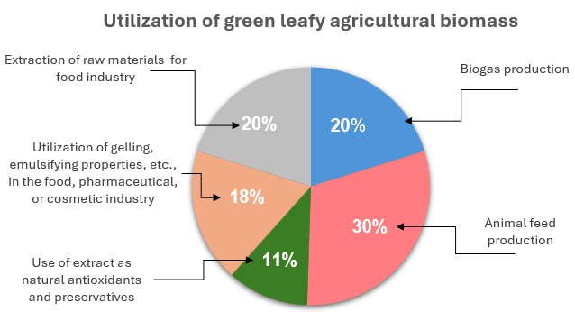

Figure 1. Survey result. The percentage distribution of participants' opinions on the current utilization of green leafy agricultural biomass.

The production of polyphenolic antioxidants (e.g., rosmarinic and chlorogenic acids), preservatives (flavonoids with antimicrobial properties), as well as natural food colorants (anthocyanins), is associated with the extraction of these compounds from plants. However, technologies involved in obtaining these substances on an industrial scale often rely on *in vitro* cultivation (Smetanska 2018). During this process, plant cells and roots are cultivated in the lab under controlled conditions, allowing for the regulation of polyphenol compounds (Smetanska 2018). However, a drawback is that such technologies are quite expensive and accessible only to large and financially stable companies, such as cosmetics brands, chemical-pharmaceutical groups, or large manufacturers in the food industry. As a result, producing necessary components from green agricultural biomass may offer financial advantages, though this requires further evaluation of profitability and comparison of outcomes with laboratory cultivation. The main reason for this evaluation is the influence of climatic conditions and yield fluctuations, which can affect the polyphenol content in plants and the overall volume of by-product production. The complexity of these questions and the lack of suitable and available technologies determined the lowest percentage of this choice.

The second part of the survey focuses on the use of plant proteins in respondents’ products and operations. Since the survey was targeted at individuals with some knowledge of plant proteins, it is important that 46% of respondents incorporate plant proteins into their work, with 83% of these proteins being produced locally. Most respondents using plant proteins were researchers who sourced proteins locally, primarily in Denmark. They mentioned Danish Technological Institute, Foulum Au (a research facility in Jutland), BioRefine Denmark A/S, which produces proteins from clover and lucerne for pig and poultry feed, and BiomassProtein, produces plant proteins from grass and common green crops. One respondent mentioned Wageningen university in Netherlands and clarified that he/she works with proteins from tomato leaves. Among producers, one used locally sourced proteins without specifying the place of production, while another imported from AGT Ingredients, one of the larger suppliers of pulses.

When assessing interest in utilizing proteins from local green agricultural biomass, it was found that half of the respondents (50%) expressing interest, including individuals who already use local proteins and wish to continue doing so. Some participants (17%), including those who currently import proteins or do not use plant proteins at all, indicated potential interest in considering local sources. The remaining participants were either unsure or not interested, citing that they do not employ them in their activities. Additionally, 54% of respondent express interest in using natural preservatives, conservatives, and antioxidants produced from green leafy agricultural biomass, while 15% were open to such possibility.

In terms of price sensitivity and customers’ willingness to pay more if products will be locally sourced and will cost more, participants were quite cautious. While 62% said they might consider paying more, only 23% fully agreed to a higher price (**Figure 2**).

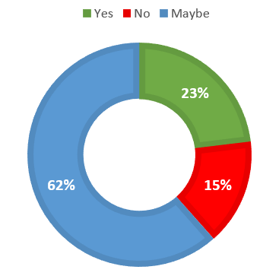This cautiousness highlights the importance of understanding market demand and the cost of local production, as there may be a gap between survey responses and real-world scenarios, where the willingness to pay more may not align with the financial capabilities of buyers.

To further explore some possible advantages and disadvantages of plant-based proteins and the utilization of local green biomass, respondents were asked to evaluate several statements. The first two statements posited that plant-based proteins could help meet the growing consumption demands in the future and that local production of proteins would contribute to the development of local economy. A large majority (85%) agreed with the statement about future demand, while 15% expressed no opinion on this matter. As for the impact on the local economy, 77% agreed with positive contribution to the development of local economy, while 23% had no opinion. These findings indicate a general recognition of the need for alternative protein sources and the pressure on the global food system. They also reflect an awareness among respondents of the value of localized food systems and their economic benefits, which can contribute to sustainable development. However, the percentage of respondents who expressed no opinion highlights the need for increased knowledge about these topics and the challenges faced by the global food system. Greater awareness could lead to more informed and sustainable choices, and potentially even encourage a shift towards plant-based diets.

Figure 2. Willingness to pay a higher price for locally produced products.

The next statement addressed the potential negative impact of plant-based protein production on animal farming and the meat and dairy industries related to demand reduction. 84% of respondents disagreed with possible negative impact on such industries, while 8% had no definitive opinion, and 8% acknowledged a possible negative impact. This majority response can be explained by the sustained high demand for meat and dairy products, which provides stability for these industries, despite the increasing interest in veganism and vegetarianism. In this context, it is also important to consider regional factors that contribute to the high proportion of animal proteins in the diet in Sweden and other Scandinavian countries. These factors include climatic conditions, which make year-round cultivation of agricultural crops unfeasible, and traditional cuisine, which influences dietary patterns and promote meat and dairy consumption.

The last statement focused on the health benefits of switching to a plant-based diet. An abundance of scientific articles and studies highlight the positive effect of plant-based diet on human health, including reductions in obesity, chronic diseases, cardiovascular problems, and diabetes (Gibbs & Cappuccio 2022). The broad range of studies also reveal the medical importance of plant polyphenolic compounds, which possess anti-inflammatory properties, capture free radicals, and are useful in the treatment of heart diseases, cancer or gastrointestinal disorders (Smetanska 2018). However, despite this, 46% of respondents expressed no opinion about health benefits. Furthermore, 15% surprisingly denied the positive impact on health, and only 38% agreed with provided statement about beneficial effects of a plant-base diet on human health.

In addition to statements evaluation, participants were asked to assess the potential ecological impact of a plant-based diet. They were first prompted to consider the FAO’s prediction of a 20% increase in demand for terrestrial animal products by 2050 (FAO 2023).

Figure 3. The opinions of survey participants on the environmental benefits of producing plant protein from green agricultural biomass (left 100% value – positive impact, right 100% value – negative impact).

With this background,participants provided theiropinions on the environmental benefits of using plant proteins from green leafy agricultural biomass (**Figure 3**). The figure shows a scale with a 0% value and two 100% values: the left value represents a positive impact, while the right value represents a negative impact. The main advantages recognized by participants include reduction of carbon dioxide emissions, preserving water and land resources compared to red meat production, and minimizing food waste by utilizing the entire plant. This last point is particularly relevant in cases where green plant residues are typically discarded in fields rather than repurposed for animal feed, biogas production, or other applications. Some respondents' opinions, suggesting that plant proteins do not directly address food waste reduction, may stem from their awareness of Sweden's efficient utilization of plant residues. Half of the respondents (50%) acknowledged that the use of plant proteins could contribute to mitigating antibiotic resistance linked to the consumption of meat containing antibiotics, while 42% considered this advantage significant. Additionally, participants recognized the potential of plant proteins to alleviate deforestation rates associated with converting land into livestock grazing areas and land for cultivating feeds like soybeans and maize for livestock.

The final aspect under consideration was the impact of increased plant protein production on biodiversity. Participants were asked to rate, on a scale from one to five, how protein production would influence species diversity (**Figure 4**). A rating of one indicated a negative impact, such as the promotion of monoculture crops, while a rating of five indicated a positive contribution to biodiversity, such as diversifying crop rotations or repurposing land previously used for grazing.

According to the results, 38% of respondents held a neutral opinion about the impact on biodiversity, believing that no changes would be observed, 8% express concern over potential negative impact, 31% perceived a slightly positive effect, and the remaining 23% maintained a very positive view on biodiversity. Such results indicate the anticipation of a positive impact on biodiversity from the increased production of plant-based proteins. However, in my opinion, this topic contains numerous nuances, such as crop rotation, intercropping, and other ways to make agriculture more sustainable, and could itself be a subject for separate research.

Figure 4. Participants' perceptions of how increased plant-based protein production from green agricultural biomass will affect biodiversity.

Summing up the survey results, the gathered responses indicate a general awareness and interest in plant-based protein and by-product from green agricultural biomass. Participants acknowledged the potential of these products to address future protein demand and contribution to the climate change mitigation, as supported by numerous studies comparing the effect of plant-based and animal-based diets. They also expressed interest in locally produced products, particularly among those already using them, which could positively influence the local economy. However, the small number of participants limits the representativeness of the finding, and the result should be interpreted as exploratory rather than definitive. Additionally, participants recognized both the potential benefits, and the challenges associated with plant-based proteins and the utilization of local biomass. The survey revealed knowledge gaps regarding the nutritional and health benefits and raised questions about the economic efficiency of producing proteins and by-products from green leafy biomass, highlighting the complexity of the topic and need of more in-depth investigation. Therefore, to build on these insights, this research proposes to examine a practical experiment in the field of proteins and polyphenols production from green agricultural biomass.

## Laboratory tests results

### 4.2.1 Results of resins treatments

The results of the first test revealed 5 resins which demonstrated a decrease in total polyphenolic compounds by more than 60% for both sugar beet and lucerne, compared to untreated controls, which had 0% reduction and are not illustrated on the figure (**Figure 5**). The remaining resins showed lower extraction and were not included in further tests.

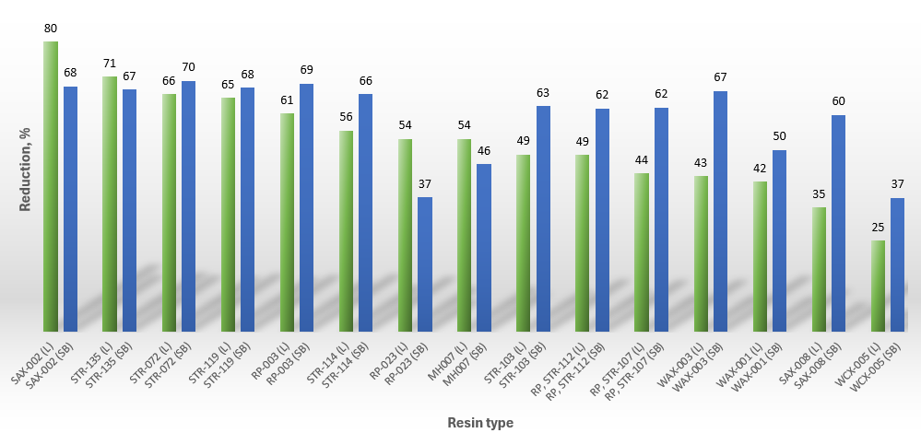

Figure 5. Reduction (%) of polyphenolic compounds for lucerne (L) and sugar beet (SB) GJ.

The weakest result was observed with the WCX-005 weak cation exchange resin, which was included to illustrate the comparative performance of the resins. Such resins bind very weakly to plant polyphenols (D’Alvise et al. 2000) and extract positively charged molecules, whereas polyphenols have a neutral or negative charge. Thus, WCX-005 was not expected to show a high reduction, serving instead to highlight the effectiveness of the other resins tested and the correction of the procedure. The resin showing the most effective results was SAX-002, a strong anion exchange resin, part of a class of resins known for their effective polyphenol extractions for a long time (D’Alvise et al. 2000). It was followed by STR-135 Pyridine, STR-072 Pyrrolidone, STR-119 Methyl Ester, and RP-003 reversed phase resin. The high level of polyphenol reduction achieved by these resins is associated with the presence of hydroxyl and carboxyl groups, as well as the aromatic rings and hydrophobic moieties present in most polyphenolic compounds, facilitating various interactions between the resin and polyphenols in the GJ of lucerne and sugar beet. The type of interaction and the chemical structure of the 5 best resins are presented in **Table 5**.

Table 5. Chemical structure of the 5 best resins and their type of interactions with polyphenolic compounds of lucerne and sugar beet GJ.

|  |  |  |
| --- | --- | --- |
| **Chemical structure** | **Name** | **Type of interactions** |
|  | **SAX-002**  Strong anion exchange resin with quaternary amine surfaces and positively charged cation N+ | *Ion interactions.* Positively charged N+ sites attract and bind negatively charged molecules of polyphenols. |
|  | **STR-135**  Pyridine with pyridine ring with nitrogen atom | *Hydrogen bond and dipole-dipole interactions*. Polar pyridine rings with N atom interact with polar groups of polyphenols. |
|  | **STR-072**  Pyrrolidone with a five-membered lactam ring and an amide functional group | *Hydrogen bond.* The amide functional group and lactam ring interact with hydroxyl and carboxyl groups of polyphenols. |
|  | **STR-119**  Methyl ester (Methacrylate) | *Van der Waals forces and hydrophobic interactions*. Non-polar and hydrophobic methyl ester groups interact with non-polar sites of polyphenols (aromatic rings, hydrophobic moieties). |
|  | **RP-003**  Reversed-phase resin with two benzene rings. | *Hydrophobic interactions* with polyphenols containing aromatic rings and hydrophobic moieties. |

It is also important to note that during the test, two strong anion exchange resins were evaluated: SAX-002 and SAX-008. SAX-002, as previously mentioned, showed promising results in polyphenol extraction, while SAX-008 exhibited one of the worst extraction percentages. The differences in reactions between these two resins can be attributed to the slightly higher cross-linking degree in SAX-002, resulting in tighter binding of polymer chains. Cross-linking is directly related to pore size in resin. Low cross-linkage results in significant swelling of the resin, leading to the formation of larger pores, which reduces the surface area available for reactions and promotes higher ion diffusion (Downey 2018). In contrast, resins with high cross-linkage have a more robust structure with many smaller pores, which reduce diffusion (Downey 2018). This difference can affect the binding of polyphenols. With the larger pores in SAX-008 and higher ion diffusion, polyphenols form fewer bonds with the resin beads. On the other hand, the higher cross-linking degree in SAX-002 creates smaller pores, providing less space for polyphenolic molecules to move freely through the resin bead and increasing the binding capacity, thereby capturing more targeted molecules.

In the second phase of the experiment, the ability of resins to extract more polyphenolic compounds by combining two different resins in a one-to-one ratio was tested. The results for sugar beet samples revealed an increased reduction rate, with the highest difference between mix and the singles at 20.5% for mix 1 (SAX-002 and STR-135), and the lowest for mixes 9 and 10 (**Figure 6**). However, the results for lucerne were not as clear. Five samples with separate resins proved to be more effective than employing a mixture of two, primarily due to the high effectiveness of SAX-002 in lucerne GJ (**Figure 7**).

Differences in the results between the two plant types suggest variations in the composition of polyphenolic compounds, each reacting differently with the chemical surfaces of the resin. In addition to this, another factor that could have positively influenced the efficiency of extraction is the increased number of resin washes. All mixtures were washed with water 5 times instead of 3 before GJ was added. The decision to increase the number of washes in this and subsequent tests was based on additional information provided by the manufacturer. It is recognized that altering the treatment process in this way may influenced the results and complicated the comparison between assays, but the adjustment was necessary to ensure the complete removal of preservatives from the resins and to enhance the accuracy of the extraction process.

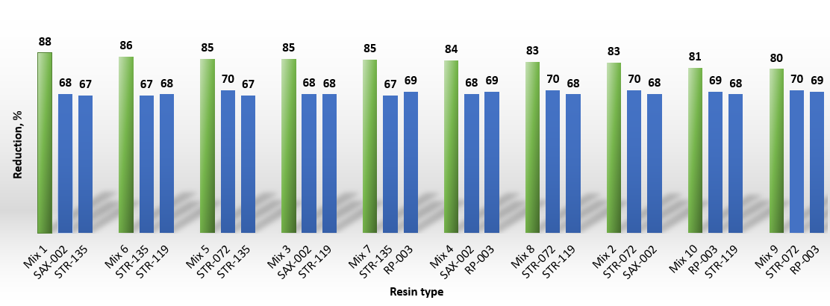

Figure 6. Reduction (%) of polyphenolic compounds for sugar beet GJ after treatment with a mixture of resins.

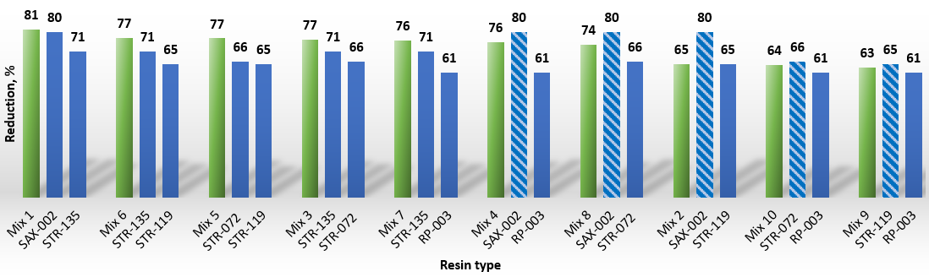

Figure 7. Reduction (%) of polyphenolic compounds for lucerne GJ after treatment with a mixture of resins.

Simultaneously, tests were conducted on variations of a single type of resin, which showed a trend towards increased extraction of polyphenols with an increase in the number of monomers in the polymer chains. Monomers, the basic building blocks of a polymer chain, bind to polymer through the process of polymerization (Helmenstine 2019). The results indicate higher amounts of polyphenol extraction with higher amounts of monomers in the resin in almost all samples, except for STR-109 (reversed phase) for sugar beet. **Figures 8 & 9** represent the total polyphenol amount in treated GJ samples compared with the untreated control (grey column). A lower value of polyphenol content indicates a higher reduction in the solution. Columns display variations of pyrrolidone (orange), pyridine (blue), HEMA (hydroxyethyl methacrylate) (green), reversed-phase resins (yellow) and two resins with nitrile functional groups (-C≡N): STR-114 and STR-141 (dark blue). STR-114 was included in the first test and displayed an average result in polyphenol extraction. Although it did not rank among the top five resins, it still showed good extraction performance. Therefore, it was decided to test its variation STR-141. The differences between STR-114 and STR-141 lie in the high cross-linking degree for STR-141 and more nitrile functionality for STR-114. The results revealed stronger extraction dependence on nitrile functional groups than on the cross-linking degree, indicating that nitrile groups have a greater impact on extraction efficiency compared to structural changes from cross-linking.

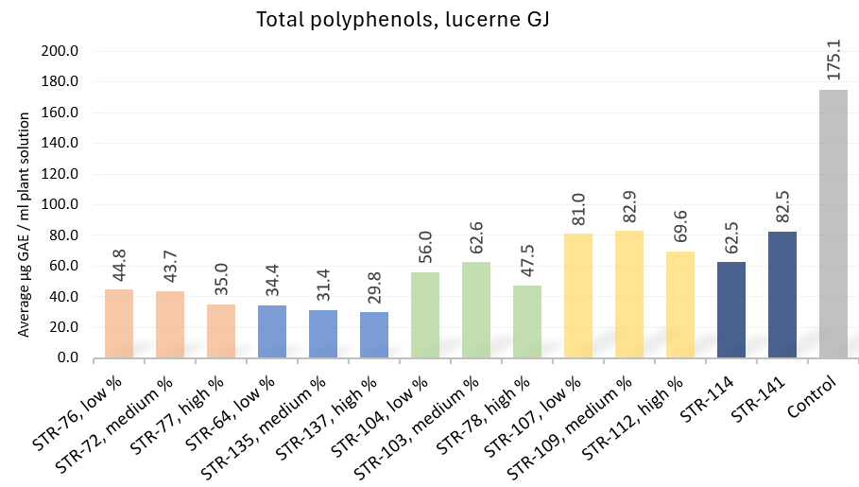

Figure 8. Total polyphenol content in lucerne GJ after treatment with variations of one type of resin (shown in the same colour).

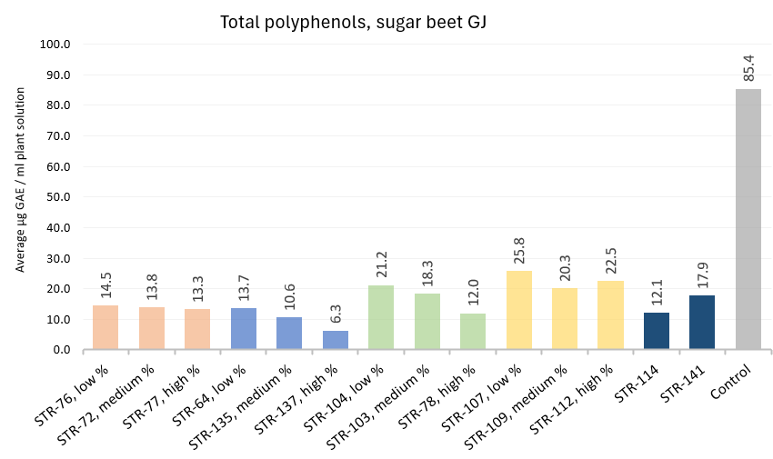

Figure 9. Total polyphenol content in sugar beet GJ after treatment with variations of one type of resin (shown in the same colour).

Overall, the combined results show the possibility of polymeric resins to successfully remove polyphenolic compounds. Reductions up to 81% were reached for lucerne GJ and 88% for sugar beet GJ with correctly selected treatments. These findings confirm part of the first hypothesis proposed in the study: specific resins can efficiently remove undesirable polyphenolic compounds from GJ extracted from lucerne and sugar beet leaves. Regarding the level of extraction, it depends on the type of resin and technology process chosen, but it can also be increased by changing pH or by a second application of new resin instead of the used one (D’Alvise et al. 2000). However, repeated applications can lead to a decrease in the amount of proteins (D’Alvise et al. 2000), which will be described in more detail later. At the same time, achieving 100% of removal seems not possible due to the presence of certain polyphenols covalently bound to proteins and/or due to polyphenols with molecular size and structure that do not allow them to bind to the resins (D’Alvise et al. 2000).

### 4.2.2 Polyphenolic compounds and HPLC results

In addition to the Folin–Ciocalteu assays indicating the total amounts, HPLC analysis was conducted to provide more information about the polyphenolic compounds. The results revealed a large reduction in polyphenol levels compared to untreated samples. These findings are illustrated in **Figures 10 a-b, 11 a-b & 12 a-b**, showing the reduction or disappearance of peak areas [mAU*s] after resin application. The images on the right side of the figures show control sample, while the left image shows just the treated samples. The separate chart in front of it shows the same treated samples at an enlarged scale, with different colours indicating various resins used.

Figure 10a. HPLC results of several **lucerne** samples from the first resin assay. The far-left picture shows treated samples at an enlarged scale. The right picture shows 8 treated samples (left side) and the control (right side). Resins: RP-003, STR-135, STR-072, STR-119, STR-114, WAX-003, SAX-002.

Figure 10b. HPLC results of several **sugar beet** samples from the first resin assay. The far-left picture shows treated samples at an enlarged scale. The right picture shows 8 treated samples (left side) and the control (right side). Resins: RP-003, STR-135, STR-072, STR-119, STR-114, WAX-003, SAX-002.

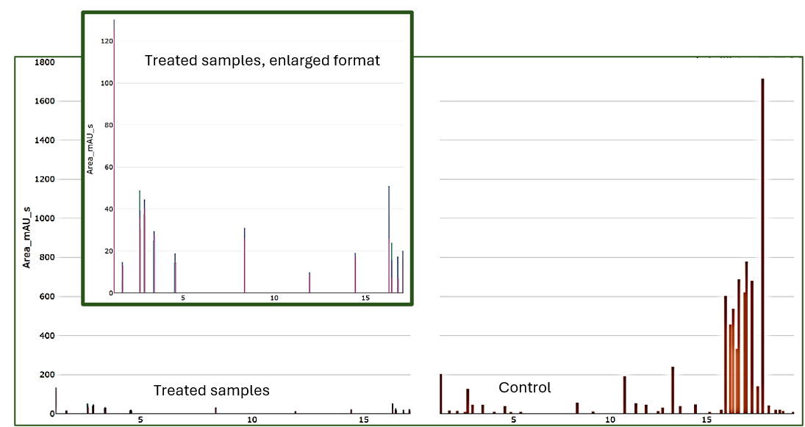

Figure 11a. HPLC results of several **lucerne** samples from the second resin assay (mix). Small chart shows treated samples at an enlarged scale. The right picture shows 4 treated samples (left side) and the control (right side). Resins: mix 1 - SAX-002+STR-135, mix 5 – STR-135+STR-072, mix 6 – STR-135+STR-119, mix 7 – STR-135+RP-003

Figure 11b. HPLC results of several **sugar beet** samples from the second resin assay (mix). Small chart shows treated samples at an enlarged scale. The right picture shows 4 treated samples (left side) and the control (right side). Resins: mix 1 - SAX-002+STR-135, mix 5 – STR-135+STR-072, mix 6 – STR-135+STR-119, mix 7 – STR-135+RP-003

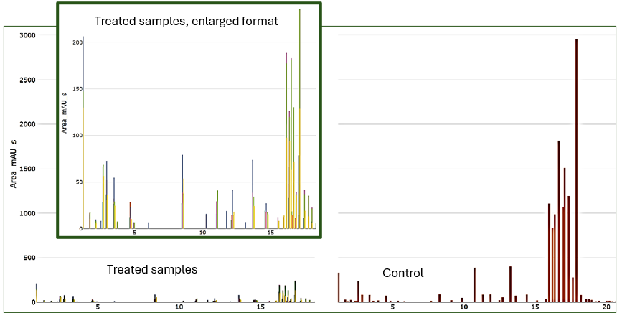

Figure 12a. HPLC results of several **lucerne** samples from the third resin assay (variants). The far-left picture shows treated samples at an enlarged scale. The right picture shows 6 treated samples (left side) and the control (right side). Resins: STR-77, STR-137, STR-78, STR-109, STR-112, STR-114.

Figure 12b. HPLC results of several **sugar beet** samples from the third resin assay (variants). The far-left picture shows treated samples at an enlarged scale. The right picture shows 6 treated samples (left side) and the control (right side). Resins: STR-77, STR-137, STR-78, STR-109, STR-112, STR-114.

**Figures 13** and **14** depict chromatogram results for one of the untreated control samples of lucerne and sugar beet, respectively. The peaks reveal a higher concentration of certain polyphenols in the lucerne untreated control sample compared to the sugar beet untreated control sample. Besides that, a greater number of individual polyphenolic compounds were observed in the lucerne sample, confirming the earlier hypothesis about the presence of different compounds in the GJ and explaining the differences in resins interactions.

Figure 13. Chromatogram of an untreated lucerne sample.

Figure 14. Chromatogram of an untreated sugar beet sample

### 4.2.3 Protein degradation: SDS-PAGE and BSA test

Electrophoretic separation of proteins revealed the presence of large subunits of RuBisCO in all samples. However, the small subunits were practically absent, which might be caused by the greater susceptibility of small subunits to environmental changes, leading to more rapid changes in their solubility or degradation. RuBisCO subunits typically ranges in molecular weight from 55kDa to 15kDa (Tanambell et al. 2022; Nynäs et al. 2024). **Figure 15** displays bright bands indicating the presence of RuBisCO units with the molecular weight 55kDa, but not 15kDa. The last column shows the ladder - a mixture of protein segments of various sizes used for visualization and identification during SDS-PAGE. It was also observed that the brightness of the bands increased for the tests conducted later, with columns 1 to 3 showing the results of the initial tests and subsequent columns showing results from later tests.

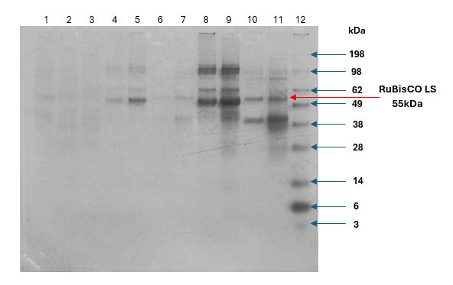

Figure 15. Results of SDS-PAGE.

**1** - Sugar beet (STR-114)

**2** - Sugar beet (SAX-002)

**3** - Lucerne (SAX-002)

**4** - Sugar beet (SAX-002 + STR-135)

**5** - Sugar beet (STR-135 + STR-119)

**6** - Lucerne (SAX-002 + STR-135)

**7** - Lucerne (STR-135 + STR-119)

**8** - Sugar beet (STR-77, 50%)

**9** - Sugar beet (control)

**10** - Lucerne (STR-77, 50%)

**11** - Lucerne (control)

**12** – Ladder

The observed changes in brightness suggest possible protein degradation, reduction, or alterations in protein solubility, which can be caused by several reasons. Firstly, the extraction of polyphenolic compounds might affect the solubility and stability of proteins in the solution. By removing polyphenols, we create conditions that alter the chemical balance of the solution. A similar effect was observed with chlorophyll in some lucerne and sugar beet samples (**Figure 16**). After applying the resin and freezing of the samples, chlorophyll formed a thin layer, making it impossible to conduct chlorophyll content test. This indicates that the resin extracted a component responsible for chlorophyll stability in the solution. A similar explanation may be applied to proteins, suggesting that their solubility was altered by polyphenol removal.

Figure 16. Precipitation of chlorophyl (green layer) in the treated lucerne sample (image by author).

Another reason for the observed changes could be related to storage time and handling methods. After resin treatment, all samples were immediately frozen to ensure preservation. However, due to the time-consuming testing processes, there was not enough time for additional analyses on the same day. As a result, the samples underwent several thawing cycles to facilitate further analyses. Considering the effect of freezing, thawing, and processing time at room temperature, these factors may have contributed to protein degradation and/or coagulation.

The last factor that could affect the concentration of proteins in the solution is the absorption of some proteins by resins. The N. D’Alvise (2000) study about removal of polyphenols and recovery of proteins from lucerne white protein concentrate mentions several cases where the application of different resins led to a decrease in protein content. One of the reasons was the excessive amount of resin, resulting in an excess of functional groups that also began to react with the proteins. The data from D’Alvise’s study indicates a progressive decrease in proteins with an increase in resin quantity, while the polyphenol content remains approximately the same (D’Alvise et al. 2000). The study also mentions the observed decrease in protein concentration when using certain resins, including anion exchange resins (like SAX-002), which is explained by the chemical bonds between proteins and resin and secondary bonding by protein to already bound phenolic compounds (D’Alvise et al. 2000). This suggests that the chemical properties of certain resins, as well as the ratio of solution to resin, can influence protein concentration and requires more thorough investigation.

Reduced protein content was also evident from the BCA test. As described in the methods section, the BCA test was conducted for two untreated samples during the first resin assay, showing protein concentration of 13.6 mg/ml for lucerne and, 17.0 mg/ml for sugar beet. At the end of the study, these same samples were tested again, revealing the reduction of protein concentration to 8.6 mg/ml and, 10.1 mg/ml respectively. It indicates a decrease in protein content even in untreated samples, which could be related just to time and storage conditions.

To further confirm protein degradation over time and under different storage conditions, we analysed untreated and unfiltered GJ leftovers from tubes preserved after the third resin test. These leftovers were thawed only once and stored in the freezer at a constant temperature. BCA analysis of these samples revealed a higher concentration of protein in both plants GJ compared to the same GJ used for subsequent research, which had undergone more frequent thawing (**Figure 17**). Such results demonstrate the effect of storage conditions and reduction of protein caused by repeated thawing and handling process.

Figure 17. Changes in BCA content with storage time. Dark grey columns – untreated leftovers from resin test 3 (variations), frozen once, light grey columns – the same untreated GJ but used as a control for tests and frozen three times.

The protein content in other samples is shown in **Figure 18** and it generally indicates a strong protein reduction in lucerne and sugar beet GJ. Given that many treated samples exhibit a greater decrease in protein levels compared to samples affected only by storage conditions, it can be argued that the reduction in soluble protein concentration is a cumulative effect of all factors, with the extraction of polyphenols and interaction with specific types of resin playing key roles. Fluctuations in sample results may occur likely due to different chemical reactions between the resins and the GJ.

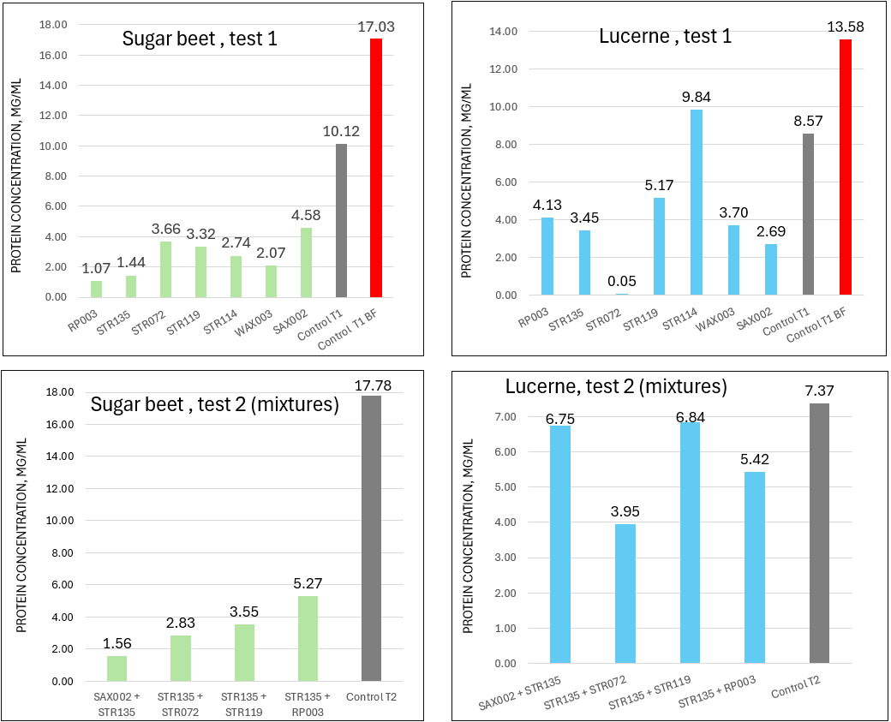

Figure 18. BCA results. Protein concentration in mg/ml. Grey columns – untreated control samples, red column – two untreated samples with protein content measured directly after the first resin assay, before freezing (BF).

The key findings of both SDS-PAGE and BCA analysis underscore the necessity of proper resin selection and sample handling, crucial for both protein purification and polyphenols extraction. Factors such as interaction time between resin and solution, the quantity and type of applied resin, as well as storage conditions must be carefully considered. Given that this project was a pilot study conducted in limited time, further, more detailed research is needed regarding the interactions between resins and proteins. Additionally, analyses should be performed on fresh samples, minimizing long-term storage, and avoiding multiple thawing and freezing cycles. Nevertheless, this project successfully demonstrated the possibility of extracting polyphenols using resins, which leads us to the discussion of the following results related to the recovery of extracted polyphenolic compounds.

### 4.2.4 Recovery of polyphenols

The final stage of the experiment aimed to recover the extracted polyphenols for further utilization as standalone products. The results of this analysis demonstrate a successful recovery of polyphenolic compounds, achieving up to 82% recoverability of bound polyphenols for sugar beet and lucerne samples (**Figure 19**). These results could potentially be improved by using stronger organic solvents, acids, bases, or their combination, depending on the resin and its bond types, as well as by adding an additional washing step.

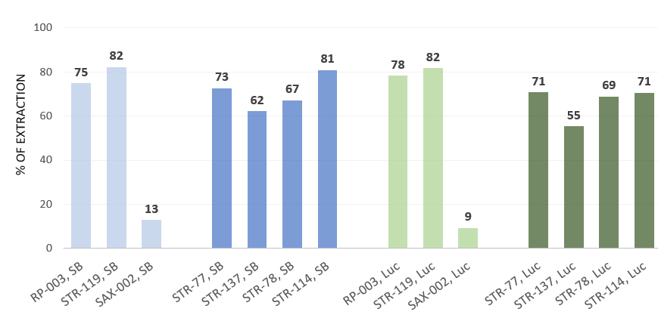

Figure 19. Percentage of recovered polyphenols. Luc-lucerne, SB - sugar beet, light blue & light green column - samples from test 1, dark blue & dark green - samples from test of variations.

The most problematic resin for the recovery of polyphenols was the strong anion exchange resin SAX-002, due to the tight binding between the polyphenol molecules and the resin beads. Attempts to extract polyphenols from this resin, following the manufacturer’s recommended protocol, were not successful. The protocol suggested using NaOH (4%), which did not give the desired results. A subsequent attempt using a combination of 70% ethanol and NaOH (4%), as also recommended, proved unsuccessful despite an extended reaction time. A third attempt, involving 80% acetone and 5M sodium chloride (NaCl) in an experimental ratio of 2 ml of 80% acetone to 3 ml of NaCl, showed a slight improvement in extraction but remained far from optimal. However, the correct method was identified later, which involved using a higher volume of 5M NaCl in combination with 96% ethanol, in a proportion of 1:15 for resin to solvent and 1:2 for 96% ethanol to 5M NaCl. Subsequent experiments washing SAX-002 with a large volume of solution showed polyphenol extraction rates exceeding 75% for lucerne and even 98% for sugar beet (**Figure 20**).

Figure 20. Percentage of recovered polyphenols from SAX-002 (additional tests). Luc-lucerne, SB - sugar beet, T1-T3 – replicates.

During the experiment, changes in both the colour of the solution and the resin were observed. As the chemical interactions between resin and phenolic compounds were interrupted, the resin colour became lighter. As for the extraction solution, it transitioned from bright yellow to transparent with washing process, which might be due to fewer chemical compounds transferring into it (**Figure 21**).

Figure 21. The change in the colour of the solution. From left to right: wash 1 (sample with a high concentration of polyphenols), wash 2, and wash 3 (almost transparent solution with minimal polyphenol content). (Image by author)

Additionally, for this experiment, the percentage of recovered polyphenols during each of the three washing stages was calculated. The data showed that during the first interaction, 32% to 60% of polyphenols transferred into the solution, followed by 11% to 21% during the second stage, and finally, 5% to 14% during the last stage. The number of washing cycles is not set and can be increased to achieve better results.

In summary, this final phase of the study achieved its goal by verifying not only the feasibility of extracting polyphenols from lucerne and sugar beet GJ but also demonstrating the possibility of their recovery for potential utilization. The conducted experiments provide valuable insights for the future optimization of the extraction process and the determination of ideal conditions for maximum polyphenol recovery.

# Conclusion

Summarizing the results, one of the hypotheses proposed in this study has been confirmed, while the second is supported by the obtained results. Firstly, polymeric resins demonstrated a high capacity for extracting polyphenolic compounds from sugar beet and lucerne green juice, with an extraction of 88%. This provides an opportunity to purify proteins and utilize the extracted polyphenols as standalone products in the food, pharmaceutical, or cosmetic industries.

Regarding the second hypothesis, the conducted survey identified a certain level of interest in proteins derived from green agricultural leafy biomass. However, the small number of participants and potential bias make it difficult to fully confirm the hypothesis about growing interest in protein and polyphenols produced from green agricultural biomass. Insights from respondents indicate some interest and need for such products, which should stimulate further research into polyphenol and protein applications across industries. Giving the limited survey data, future studies should aim to conduct more thorough survey and find new ways for distribute it among the targeted group, achieving a more representative outcome.

Participants’ perceptions show that plant-based proteins are viewed as more sustainable than animal-derived proteins in terms of their environmental impact. Moreover, utilizing plant residues containing relatively high protein concentrations aligns with the growing population's demand for protein-rich food, and efforts to reduce waste. This, in turn, supports Sustainable Development Goals (SDG) as Zero Hunger (SDS №2), Good Health and Well-being (SDS №3), and Responsible Consumption and Production (SDS №12).

As this study was a pilot project, it highlights several directions for future,

more detailed research. These include studying the interaction between resins and proteins, the influence of polyphenolic components on protein solubility, exploration of various methods of polyphenols extraction bound to polymer resin, as well as more broader studies about the application of extracted polyphenols, research in food waste management, or studying the impact of plant protein production on agriculture, biodiversity, foodscapes, and human health.

Furthermore, this project illustrates many possible connections between food, landscape, and people and provides a theoretical background for future study. In other words, it lays the foundation for the next steps in research, which will be more thorough, extensive and focus on the interaction between polymeric resins, protein, and polyphenols. The culmination of this research will be presented in the form of a scientific article later.

References

Abdo, E., El-Sohaimy, S., Shaltout, O., Abdalla, A., & Zeitoun, A. (2020). Nutritional Evaluation of Beetroots (Beta vulgaris L.) and Its Potential Application in a Functional Beverage. *Plants*, 9(12), 1752. https://doi.org/10.3390/plants9121752

Akyüz, A. & Ersus, S. (2021). Optimization of enzyme assisted extraction of protein from the sugar beet (*Beta vulgaris* L.) leaves for alternative plant protein concentrate production. *Food Chemistry*, 335, 127673. https://doi.org/10.1016/j.foodchem.2020.127673

Alara, O. R., Abdurahman, N. H., & Ukaegbu, C. I. (2021). Extraction of phenolic compounds: A review. *Current Research in Food Science*, 4, 200–214. https://doi.org/10.1016/j.crfs.2021.03.011

Anoop, A.A., Pillai, P.K.S., Nickerson, M. & Ragavan, K.V. (2023). Plant leaf proteins for food applications: Opportunities and challenges. *Comprehensive Reviews in Food Science and Food Safety*, 22 (1), 473–501. https://doi.org/10.1111/1541-4337.13079

Aramrueang, N., Zicari, S.M. & Zhang, R. (2017). Response Surface Optimization of Enzymatic Hydrolysis of Sugar Beet Leaves into Fermentable Sugars for Bioethanol Production. *Advances in Bioscience and Biotechnology*, 8 (2), 51–67. https://doi.org/10.4236/abb.2017.82004

Arfaoui, L. (2021). Dietary Plant Polyphenols: Effects of Food Processing on Their Content and Bioavailability. *Molecules*, 26 (10), 2959. https://doi.org/10.3390/molecules26102959

Balfany, C., Gutierrez, J., Moncada, M. & Komarnytsky, S. (2023). Current Status and Nutritional Value of Green Leaf Protein. *Nutrients*, 15 (6), 1327. https://doi.org/10.3390/nu15061327

Biondo, P. B. F., Boeing, J. S., Barizão, É. O., Souza, N. E. de, Matsushita, M., Oliveira, C. C. de, Boroski, M., & Visentainer, J. V. (2014). Evaluation of beetroot (Beta vulgaris L.) leaves during its developmental stages: A chemical composition study. *Food Science and Technology*, 34, 94–101. https://doi.org/10.1590/S0101-20612014005000007

BiomassProtein (n.d.). *BIOMASSPROTEIN™*.​​ <https://biomassprotein.com/> [2024-09-06]

BioRefine (n.d.). *Om BioRefine.* <https://biorefine.dk/p/om-biorefine> [2024-09-06]

Bouton, J. (2012). An overview of the role of lucerne (Medicago sativa L.) in pastoral agriculture. *Crop and Pasture Science*, 63, 734. https://doi.org/10.1071/CP12127

Cosun (2023). *Cosun annual report 2022*. https://www.cosun.com/news/cosun-annual-report-2022/ [2024-03-04]

D’Alvise, N., Lesueur-Lambert, C., Fertin, B., Dhulster, P. & Guillochon, D. (2000). Removal of Polyphenols and Recovery of Proteins from Alfalfa White Protein Concentrate by Ultrafiltration and Adsorbent Resin Separations. *Separation Science and Technology*, 35 (15), 2453–2472. https://doi.org/10.1081/SS-100102349

dos Santos, F. K. F., de Rezende, C. M., & da Veiga Júnior, V. F. (2022). Macroporous polymeric resins as a tool to obtain bioactive compounds in food and food-waste: A review. *Journal of Food Composition and Analysis*, 114, 104703. https://doi.org/10.1016/j.jfca.2022.104703

Downey, D.D. (2018). Ion Exchange Resin—Pilot and Resin Testing. In: Davis, B., et al. *Extraction 2018*. The Minerals, Metals & Materials Series. Springer, Cham. https://doi-org.ludwig.lub.lu.se/10.1007/978-3-319-95022-8_175

Drewnowski, A. & Gomez-Carneros, C. (2000). Bitter taste, phytonutrients, and the consumer: a review. *The American Journal of Clinical Nutrition*, 72 (6), 1424–1435. https://doi.org/10.1093/ajcn/72.6.1424

Ducrocq, M., Boire, A., Anton, M., Micard, V. & Morel, M.-H. (2020). RuBisCO: A promising plant protein to enrich wheat-based food without impairing dough viscoelasticity and protein polymerisation. *Food Hydrocolloids*, 109, 106101. https://doi.org/10.1016/j.foodhyd.2020.106101

Dudzik, M. (2022). The origins of the French beet sugar industry (1806-1815). *Proceedings of the International Student Scientific Conference Poster*.

https://www.academia.edu/83828320/The_origins_of_the_French_beet_sugar_industry_1806_1815_ [2024-04-07]

Dukić, J., Košpić, K., Kelava, V., Mavrić, R., Nutrizio, M., Balen, B., Butorac, A., Halil Öztop, M. & Režek Jambrak, A. (2023). Alternative methods for RuBisCO extraction from sugar beet waste: A comparative approach of ultrasound and high voltage electrical discharge. *Ultrasonics Sonochemistry*, 99, 106535.

https://doi.org/10.1016/j.ultsonch.2023.106535

Ecolab (n.d.-a). *Ion Exchange Resin Characteristics*. Ecolab. <https://www.purolite.com/index/core-technologies/industry/food-and-beverage/sweetener-applications/corn-sweetener-refining-with-ion-exchange-resins/ion-exchange-resin-characteristics> [2024-09-11]

Ecolab (n.d.-b). *Oil and Gas Products.* Ecolab. https://www.purolite.com/index/core-technologies/industry/oil-and-gas [2024-09-12]

EFSA (n.d.). *Summary of applications and notifications. Application 2021. Beer Leaf protein (Beta vulgaris L.).* https://food.ec.europa.eu/safety/novel-food/authorisations/summary-applications-and-notifications_en [2024.03.20]

EFSA (2009). Opinion on the safety of ‘Alfalfa protein concentrate’ as food. *EFSA Journal*, *7*(4), 997. https://doi.org/10.2903/j.efsa.2009.997

ETS No. 176 (2004). *Council of Europe Landscape Convention (ETS No. 176)*. https://www.coe.int/en/web/conventions/full-list?module=treaty-detail&treatynum=176 [2024-01-20]

FAO (n.d.). *Sugar beet*. https://www.fao.org/land-water/databases-and-software/crop-information/sugarbeet/fr/ [2024-04-15]

FAO (2023). *New FAO report maps pathways towards lower livestock emissions.* https://www.fao.org/newsroom/detail/new-fao-report-maps-pathways-towards-lower-livestock-emissions/en [2024-01-15]

Fuentes, M. & Fuentes, C. (2022). Reconfiguring food materialities: plant-based food consumption practices in antagonistic landscapes. *Food, Culture & Society*, 25 (3), 520–539. https://doi.org/10.1080/15528014.2021.1903716

FVM (2023). Danish strategy for green proteins for animals and humans. Ministry of Food, Agriculture and Fisheries of Denmark. <https://fvm.dk/Media/638524902251150869/Strategy_green_Proteins_2024.pdf> [2024-09-09]

Ghaleb, W., Ahmed, L.Q., Escobar-Gutiérrez, A.J. & Julier, B. (2021). The History of Domestication and Selection of Lucerne: A New Perspective from the Genetic Diversity for Seed Germination in Response to Temperature and Scarification. *Frontiers in Plant Science*, 11, 578121. https://doi.org/10.3389/fpls.2020.578121

Gibbs, J. & Cappuccio, F.P. (2022). Plant-Based Dietary Patterns for Human and Planetary Health. *Nutrients*, 14 (8). https://doi.org/10.3390/nu14081614

Green Protein Project (2019). *About the project*. https://greenproteinproject.eu/ [2024-03-04]

Hadidi, M., Hossienpour, Y., Nooshkam, M., Mahfouzi, M., Gharagozlou, M., Aliakbari, F.S., Aghababaei, F. & McClement, D.J. (2023). Green leaf proteins: a sustainable source of edible plant-based proteins. *Critical Reviews in Food Science and Nutrition*, 0 (0), 1–18. https://doi.org/10.1080/10408398.2023.2229436

Helmenstine, A.M., (2019). Monomers and Polymers in Chemistry. *ThoughtCo*, thoughtco.com/monomers-and-polymers-intro-608928 [2024-04-18]

Henchion, M., Hayes, M., Mullen, A.M., Fenelon, M. & Tiwari, B. (2017). Future Protein Supply and Demand: Strategies and Factors Influencing a Sustainable Equilibrium. *Foods*, 6 (7), 53. https://doi.org/10.3390/foods6070053

Hänggli, A., Levy, S. A., Armenteras, D., Bovolo, C. I., Brandão, J., Rueda, X., & Garrett, R. D. (2023). A systematic comparison of deforestation drivers and policy effectiveness across the Amazon biome. Environmental Research Letters, 18(7), 073001. https://doi.org/10.1088/1748-9326/acd408

Julier, B., Gastal, F., Louarn, G., Badenhausser, I., Annicchiarico, P., Crocq, G., Chatelier, D., Guillemot, E. & Emile, J. (2017). Lucerne (Alfalfa) in European cropping systems. In: Legumes in Cropping Systems. https://doi.org/10.1079/9781780644981.0168

Kammerer, D.R., Kammerer, J. & Carle, R. (2014). Chapter 11 - Resin Adsorption and Ion Exchange to Recover and Fractionate Polyphenols. In: Watson, R.R. (ed.) *Polyphenols in Plants*. Academic Press. 219–230. https://doi.org/10.1016/B978-0-12-397934-6.00011-5

Kammerer, D. R., Kammerer, J., & Carle, R. (2019). Chapter 19 - Adsorption and Ion Exchange for the Recovery and Fractionation of Polyphenols: Principles and Applications. In R. R. Watson (Ed.), Polyphenols in Plants (Second Edition) (pp. 327–339). Academic Press. https://doi.org/10.1016/B978-0-12-813768-0.00018-9

Lamsal, B.P., Koegel, R.G. & Gunasekaran, S. (2007). Some physicochemical and functional properties of alfalfa soluble leaf proteins. LWT - Food Science and Technology, 40 (9), 1520–1526. https://doi.org/10.1016/j.lwt.2006.11.010

Leaft Foods (n.d.). *Our Journey*. https://www.leaftfoods.com/about/ [2024-03-04]

Liese, H.W., Valkenburg, T.A.A., America, A.H.P., Scholten, E. & Bruins, M.E. (2023). Toxin removal during protein extraction from tomato leaves. *Innovative Food Science & Emerging Technologies*, 88, 103454. https://doi.org/10.1016/j.ifset.2023.103454

Luzixine TM (n.d.). *LUZIXINE*. https://luzixine.fr/en/origins/ [2024-03-04]

Martillanes, S., Rocha-Pimienta, J., Cabrera-Bañegil, M., Martín-Vertedor, D., Delgado-Adámez, J., Martillanes, S., Rocha-Pimienta, J., Cabrera-Bañegil, M., Martín-Vertedor, D. & Delgado-Adámez, J. (2017). Application of Phenolic Compounds for Food Preservation: Food Additive and Active Packaging. *Phenolic Compounds - Biological Activity*. IntechOpen. https://doi.org/10.5772/66885

Nynäs, A.-L. (2022). *Harnessing the potential of green leaves - Agricultural biomass as a source of sustainable food protein.* [Acta Universitatis Agriculturae Sueciae](https://publications.slu.se/?file=jour/show&cid=17229288&lang=en)  
2022, number: 2022:23. https://publications.slu.se/?file=publ/show&id=116660

Nynäs, A.-L., Berndtsson, E., Newson, W.R., Hovmalm, H.P. & Johansson, E. (2024). Protein Fractionation of Leafy Green Biomass at the Pilot Scale: Partitioning and Type of Nitrogen in the Fractions and Their Usefulness for Food and Feed. *ACS Food Science & Technology*, 4 (1), 126–138. https://doi.org/10.1021/acsfoodscitech.3c00426

OECD (2006). *Safety Assessment of Transgenic Organisms, Volume 1: OECD Consensus Documents Section 8 - Sugar Beet (BETA VULGARIS L.)*. https://read.oecd-ilibrary.org/science-and-technology/safety-assessment-of-transgenic-organisms/section-8_9789264095380-11-en#page1. [2024-04-15]

Olsson, R. (2004). Environmental aspects of Sugar Beet Production in Sweden. SBU Sockernäringens Betodlings Utveckling. NBR Nordic Beet Research. https://www.nordicbeet.nu/wp-content/uploads/2017/02/environmental-aspects-of-sugar-beet-production-in-sweden.pdf [2024-04-17]

Prakash, S., Gaiani, C. & Bhandari, B.R. (2023). Chapter 1 - Plant-based food as a sustainable source of food for the future. In: Prakash, S., Bhandari, B.R., & Gaiani, C. (eds) *Engineering Plant-Based Food Systems*. Academic Press. 1–12. https://doi.org/10.1016/B978-0-323-89842-3.00005-1

Puccinelli, M., Carmassi, G., Botrini, L., Bindi, A., Rossi, L., Fierro-Sañudo, J. F., Pardossi, A., & Incrocci, L. (2022). Growth and Mineral Relations of Beta vulgaris var. Cicla and Beta vulgaris ssp. Maritima Cultivated Hydroponically with Diluted Seawater and Low Nitrogen Level in the Nutrient Solution. *Horticulturae, 8*(7), Article 7. https://doi.org/10.3390/horticulturae8070638

Purolite (2023). *Polymeric Adsorbent Resins for Industrial Applications.* Purolite An Ecolab Company.https://www.purolite.com/dam/jcr:f016decb-bf8a-4b06-b5f7-1673fad6b255/industrial-adsorbents-brochure.pdf [2024-03-18]

Purolite (2024). *Food and Beverage products.* Purolite An Ecolab Company. https://www.purolite.com/index/core-technologies/industry/food-and-beverage [2024-03-18]

Raderschall, C., Bommarco, R., Lindström, S. & Lundin, O. (2021). Landscape crop diversity and semi-natural habitat affect crop pollinators, pollination benefit and yield. *Agriculture Ecosystems & Environment*, 306, 107189. https://doi.org/10.1016/j.agee.2020.107189

Redstone Separation (n.d.). *Tailored resins for challenging purifications*. Redstone Separations AB. <https://redstone-sep.com/productshead/selective-resins/> [2024-09-11]

Redstone Separation (2023) *Resins for aqueous applications.* *TEMIZ tm – Generic resins. Product overview.* Version 2023-V1. Redstone Separations AB. <https://redstone-sep.com/productshead/generic-resins-aqueous/> [2024-09-11]

RuBisCO Foods (n.d.). *Alfalfa Protein Concentrate (APC-50)*. https://RuBisCOfoods.com/producten/alfalfa-protein-concentrate-apc-50/ [2024-03-04]

Russelle, M.P. (2001). Alfalfa: After an 8,000-year journey, the ‘Queen of Forages’ stands poised to enjoy renewed popularity. *American Scientist*, 89 (3), 252–261

Sabaté, J. & Soret, S. (2014). Sustainability of plant-based diets: back to the fututre. *The American Journal of Clinical Nutrition*, 100, 476S-482S. https://doi.org/10.3945/ajcn.113.071522

Scarborough, P., Clark, M., Cobiac, L., Papier, K., Knüppel, A., Lynch, J., Harrington, R., Key, T. & Springmann, M. (2023). Vegans, vegetarians, fish-eaters and meat-eaters in the UK show discrepant environmental impacts. *Nature Food*, 4, 1–10. https://doi.org/10.1038/s43016-023-00795-w

Silva, M., Castellanos, L. & Ottens, M. (2018). Capture and Purification of Polyphenols Using Functionalized Hydrophobic Resins. *Industrial & Engineering Chemistry Research*, 57 (15), 5359–5369. https://doi.org/10.1021/acs.iecr.7b05071

Smetanska, I. (2018). Sustainable Production of Polyphenols and Antioxidants by Plant In Vitro Cultures. In: Pavlov, A. & Bley, T. (eds) *Bioprocessing of Plant In Vitro Systems*. Springer International Publishing. 225–269. https://doi.org/10.1007/978-3-319-54600-1_2

Sridhar, A., Ponnuchamy, M., Kumar, P. S., Kapoor, A., Vo, D.-V. N., & Prabhakar, S. (2021). Techniques and modeling of polyphenol extraction from food: A review. *Environmental Chemistry Letters*, 19(4), 3409–3443. https://doi.org/10.1007/s10311-021-01217-8

Suwignyo, B., Aristia Rini, E. & Helmiyati, S. (2023). The profile of tropical alfalfa in Indonesia: A review. *Saudi Journal of Biological Sciences*, 30 (1), 103504. https://doi.org/10.1016/j.sjbs.2022.103504

Tamayo Tenorio, A., Schreuders, F.K.G., Zisopoulos, F.K., Boom, R.M. & van der Goot, A.J. (2017). Processing concepts for the use of green leaves as raw materials for the food industry. *Journal of Cleaner Production*, 164, 736–748. https://doi.org/10.1016/j.jclepro.2017.06.248

Tanambell, H., Møller, A.H., Corredig, M. & Dalsgaard, T.K. (2022). RuBisCO from alfalfa – native subunits preservation through sodium sulfite addition and reduced solubility after acid precipitation followed by freeze-drying. *LWT*, 154, 112682. https://doi.org/10.1016/j.lwt.2021.112682

Tanambell, H., Danielsen, M., Devold, T. G., Møller, A. H., & Dalsgaard, T. K. (2024). In vitro protein digestibility of RuBisCO from alfalfa obtained from different processing histories: Insights from free N-terminal and mass spectrometry study. Food Chemistry, 434, 137301. https://doi.org/10.1016/j.foodchem.2023.137301

Tazeddinova, D., Rahman, M., Hamdan, S., Matin, M., Bakri, M.K. & Rahman, M. (2022). Plant Based Polyphenol Associations with Protein: A Prospective Review. *Bioresources*, 17, 7110–7134. https://doi.org/10.15376/biores.17.4.Tazeddinova2

Thakur, S., Pandey, A.K., Verma, K., Shrivastava, A. & Singh, N. (2024). Plant-based protein as an alternative to animal proteins: A review of sources, extraction methods and applications. *International Journal of Food Science & Technology*, 59 (1), 488–497. https://doi.org/10.1111/ijfs.16663

United Nations, U. (n.d.-b). *Population*. *United Nations*. https://www.un.org/en/global-issues/population [2024-01-15]

Vonthron, S., Perrin, C. & Soulard, C.-T. (2020). Foodscape: A scoping review and a research agenda for food security-related studies. *PLoS ONE*, 15 (5), e0233218. https://doi.org/10.1371/journal.pone.0233218

Yilmaz, E., Westall, A., Jönsson, S. (n.d.). *Designed polymers for purification of flavour oils in industrial scale.* [Poster] MIP Technologies AB, Lund, Sweden.

Zhang, Y., Cai, P., Cheng, G., & Zhang, Y. (2022). A Brief Review of Phenolic Compounds Identified from Plants: Their Extraction, Analysis, and Biological Activity. *Natural Product Communications*, 17(1), 1934578X211069721.

https://doi.org/10.1177/1934578X211069721

Popular science summary

The increasing global population and consequently the demand for food, are driving the search for ways to address this growing need. One potential source of additional proteins is green agricultural biomass (e.g., tomato leaves, sugar beet or carrot tops), typically used for biogas production or animal feed. In this study, we investigated the need for such proteins, as well as polyphenols, which are plant responses to such stresses as drought, diseases, or pests. The list of these compounds is extensive, as is their range of applications, starting from natural food colorants and preservatives to medicine production. One method of obtaining such polyphenols involves the use of polymeric resins. Due to their chemical properties, they bind polyphenols in the juice extracted from pressed biomass and absorb them like a sponge. The results of this work demonstrated a high degree of extraction and subsequent recovery of polyphenols, while also contributing to the purification of proteins themselves, to which polyphenols can cause a bitter or astringent taste. Additionally, this work highlights the interest in both plant proteins and polyphenols, which could potentially advance the development of this field, promote the use of local agricultural biomass, and contribute to circular production and sustainability efforts.

-------------------------------------------------------

Den ökande globala befolkningen och därmed efterfrågan på livsmedel driver sökandet efter sätt att adressera detta växande behov. En potentiell källa till ytterligare proteiner är grön biomassa (e.g., tomatblad, sockerbetsblast, morotsblast), som vanligtvis används för biogasproduktion eller djurfoder. I denna studie undersökte vi behovet av sådana proteiner, liksom polyfenoler. Polyfenoler är växters svar på stressfaktorer som torka, sjukdomar eller skadedjur. Listan över dessa föreningar är omfattande, liksom deras användningsområden, som sträcker sig från naturliga livsmedelsfärgämnen och konserveringsmedel till medicinproduktion. En metod för att rena uppsådana polyfenoler innefattar användning av polymerharts. På grund av sina kemiska egenskaper binder de polyfenoler i saften som extraheras från pressad biomassa och absorberar dem som en svamp. Resultaten av detta arbete visade på en hög grad av extraktion och efterföljande upprening av polyfenoler, samtidigt som det bidrog till utvinningen av själva proteinerna, till vilka polyfenoler kan ge en bitter eller sträv smak. Dessutom visar detta arbete på intresset för både växtproteiner och polyfenoler, vilket potentiellt kan främja utvecklingen av detta område, öka användningen av lokal grön biomassa och bidra till cirkulär produktion och hållbarhet.

Acknowledgements

I extend my sincere gratitude to my thesis supervisor, Dr. Anna-Lovisa Nynäs, for providing me with the opportunity to undertake this project. Without her help, guidance, responsiveness, unwavering support regardless of the results, and willingness to answer my endless questions, this project would not have been achievable.

I am also deeply grateful to my co-supervisor, Dr. Anna Peterson, for her contribution, approval of the plant protein topic, and ideas how to integrate this subject into my thesis for Food and Landscape master's program. This task would have been incredibly challenging without your advice.

A special acknowledgment is to my industrial supervisor, Ecevit Yilmaz, his colleague Masahiro Iwata, and Redstone Separations AB for their invaluable explanations and provision of materials, which formed the core of this project.

I am also grateful to Livsmedelsakademin for granting me access to their resources for distributing the survey, which proved instrumental in gathering crucial data. I would also like to thank Partnerskap Alnarp for financial support for the project.

Lastly, I would like to recognize my colleagues Anders Ekholm, Beatrice Lilja, Waleed Mlook, Oksana Korniienko, and others from the Plant Product Quality Group of the Plant Breeding Department, for their assistance with experiments, tests, and for contributing to a supportive working environment and friendly atmosphere.

Appendix 1

Survey: Plant Protein Perspectives: Assessing Public Views and Beliefs.

Welcome and thank you for your interest!

How much do you know about proteins from agricultural green biomass?

Please share your opinions and thoughts by answering the following questions.

Your perspective is extremely important to us!

**What are plant proteins from green agricultural biomass?**

**Info:** The search for sustainable alternative protein sources has been actively driving research into the extraction of proteins from green agricultural biomass, such as leaves from sugar beets, lucerne, spinach, kale, and more.

Proteins extracted in this manner, as well as by-products like polyphenolic compounds with antimicrobial, antioxidant, preservative, and anti-inflammatory properties, contribute to a more sustainable, plant-centric approach to nutrition. Additionally, they hold significant potential for use not only in the food industry but also in pharmaceutical and cosmetic sectors as natural preservatives, conservatives, and antioxidants.

**Background Information**

1. **Please list your occupation.**

Producer/Employee in Food Industry

Producer/Employee in Pharma or Cosmetic Industry

Farmer

Researcher

Other

1. **Do you consider plant-based proteins, with various functional properties (gelling, foaming, emulsifying, etc.), as an important component in the food industry?**

Yes

No

Maybe

1. **Do you consider plant-based protein as an option to animal protein in food products?**

Yes

No

Maybe

1. **How familiar are you with plant-based protein derived from green leafy agricultural biomass (lucerne, sugar beet, etc.)?**

Very familiar

Somewhat familiar

Not so familiar

Not familiar at all

1. **Please indicate the areas in which you are certain about the use of green leafy agricultural biomass.**

Biogas production

Animal feed production

Extraction of raw material for food industry

Utilization of gelling, emulsifying properties, etc., in the food, pharmaceutical, or cosmetic industry

Use of extracts as natural antioxidants and preservatives

**Usage of Proteins**

1. **Are you today using some type of plant-based protein in your products or operations? \***

Yes

No

1. **Are these proteins produced locally?**

Yes

No

1. **Please specify the place, and if possible, the company of the protein manufacturer.**
2. **Are you interested in incorporating plant-based protein derived from local green leafy agriculture biomass into your products or operations?**

Yes

No

Maybe

I don’t know.

1. **Are you interested in using natural preservatives, conservatives and antioxidants produced from green leafy agricultural biomass in your products or operations?**

Yes

No

Maybe

I don’t know.

1. **Would you be willing to pay more for locally produces plant-based proteins?**

Yes

No

Maybe

**Social, economic, and environmental aspects**

Please answer whether you agree or disagree with the following statements.

1. **What environmental benefits do you foresee from the production of plant-based proteins from green agriculture biomass?**

Please keep in mind that Food and Agriculture Organization of the United Nation prognoses 20% increase in demand for terrestrial animal products by 2050.

1. **Please rate, on a scale from 1 to 5, your perception on how an increased plant-based protein production from green agricultural biomass will affect biodiversity.**

**1** - representing a negative impact (e.g., increased monoculture, etc.)

**5** - representing a positive impact (e.g., reduced use of land and grassland for animal husbandry, etc.)

Survey is also available in Swedish language. Link - https://forms.office.com/e/sr60xmm7kM

Appendix 2

#### **Table of tested resins.**

|  |  |  |  |
| --- | --- | --- | --- |
|  | Resin or Batch Nr. | Category | Comments |
| 1 | RP-003 | RP, Reversed phase | Low % of monomeric units |
| 2 | STR-107 | RP, Reversed phase | Low % of monomeric units |
| 3 | STR-109 | RP, Reversed phase | Medium % of monomeric units |
| 4 | STR-112 | RP, Reversed phase | High % of monomeric units |
| 5 | RP-023 | RP-isobutyl, Reversed phase | Low % of monomeric units |
| 6 | STR-78 | HEMA, Intermediate polar, RP | High % of monomeric units |
| 7 | STR-103 | HEMA, Intermediate polar, RP | Medium % of monomeric units |
| 8 | STR-104 | HEMA, Intermediate polar, RP | Low % of monomeric units |
| 9 | STR-64 | Pyridine, Intermediate polar, RP | Low % of monomeric units |
| 10 | STR-135 | Pyridine, Intermediate polar, RP | Medium % of monomeric units |
| 11 | STR-137 | Pyridine, Intermediate polar, RP | High % of monomeric units |
| 12 | STR-072 | Pyrrolidone, Intermediate polar, RP | Medium % of monomeric units |
| 13 | STR-076 | Pyrrolidone, Intermediate polar, RP | Low **%** of monomeric units |
| 14 | STR-077 | Pyrrolidone, Intermediate polar, RP | High **%** of monomeric units |
| 15 | STR-119 | Methyl Ester, Intermediate polar, RP |  |
| 16 | STR-114 | Nitrile, Intermediate polar, RP |  |
| 17 | STR -141 | Nitrile, Intermediate polar, RP |  |
| 18 | WAX-003 | Weak Anion Exchange |  |
| 19 | WAX-001 | Weak Anion Exchange |  |
| 20 | SAX-008 | Strong Anion Exchange |  |
| 21 | SAX-002 | Strong Anion Exchange |  |
| 22 | MH007 | DVB-Amide resin |  |
| 23 | WCX-005 | Weak Cation Exchange |  |

Appendix 3

#### **Protocol 1: The Folin–Ciocalteu assay** (**Measurement of Total polyphenols in GJ)**

*(Masahiro Iwata, 2024)*

Materials and reagents:

* Gallic acid standards in distilled water with concentrations of 0, 0.125, 0.25, 0.5, 1, and 2 mM, respectively. Zero concentration refers to Milli-Q water.
* Folin’s reagent
* 7% (w/v) Na2CO3 in water

Protocol:

1. Pipette 12 μL of each sample into separate wells of 96-well plate, with 3 replicas for each sample.
2. Add 12 μL of gallic acid standards into separate wells, with 3 replicas for each concentration.
3. Add 50 μL of Milli-Q water into each well, including standards.
4. Add 12 μL of Folin’s reagent into each well, including standards, and incubate for 6 minutes.
5. Add 125 μL of pre-mixed 7% (w/v) Na2CO3 in water to each well, including standards.
6. Incubate for 75 minutes.
7. Analise total polyphenolic compounds using a microplate reader spectrophotometer, with absorbance 765 nm.

#### **Protocol 2: HPLC**

1. Prepare samples: Put 1 ml of sample into HPLC vial. Prepare blank sample with 1 ml of MilliQ water.
2. Prepare solvents used for eluting.
3. Create a new method (if needed) for HPLC analyses according to parameters below.

UPLC Agilent 1260 MSD 6120b

|  |  |  |  |  |
| --- | --- | --- | --- | --- |
| **Method for analysis of polyphenols in various plant matrices. (Metod för analys av polyfenoler I diverse växtmatriser, LC-analys fenoler med LC-DAD_MS)** | | | | |
|  | |
| Column | YMC TriArt 150*3mm, 3μm, 8 nm | | |  | |
| Injection | 5 μl (10 μl in some cases) | | |  | |
| Flow | 0.65 ml/min | | |  | |
| Eluent A | 0.5% HCOOH | | |  | |
| Eluent B | 0,5% HCOOH in Acetonitril | | |  | |
|  |  |  |  |  | |
| Binary gradient |  |  |  |  | |
|  |  |  |  |  | |
| Time (min) | %A | %B |  |  | |
| 0 | 90 | 10 |  |  | |
| 3 | 90 | 10 |  |  | |
| 13 | 85 | 15 |  |  | |
| 16 | 75 | 25 |  |  | |
| 22 | 65 | 35 |  |  | |
| 23 | 90 | 10 |  |  | |
| 27 | 90 | 10 |  |  | |
|  |  |  |  |  | |
| Detectors |  |  |  |  | |
|  |  |  |  |  | |
| DAD | Sampling rate, 2,5 hz | | |  | |
|  |  |  |  |  | |
| Wavelength collect 320 used for quantification | 280 nm | 320 nm | 350 nm |  | |
| Spectra | 220-550 nm (1nm) | | |  | |
| MSD |  |  |  |  | |
| API-ES | Negative |  |  |  | |
| Scan signal start at 1.5 min. mass range 130-1100 fragmentor 50V |  |  |  |  | |
| Spray chamber |  | 300 °C |  |  | |
| Drying gas |  | 12 l/min |  |  | |
| Nebulizer |  | 60 psi |  |  | |
| Quad temp |  | 100 °C |  |  | |
| Vcap+ |  | 3000 V |  |  | |
| Vcap- |  | 3500 V |  |  | |

#### **Protocol 3: SDS-PAGE minigel electrophoresis kit** (Anna-Lovisa Nynäs, 2016-12-08 (Updated by Olga Gladchuk 2024-04-04))

Materials and reagents

* Reducing agent (Novex Bolt™ Sample reducing agent (10 X))
* Sample buffer (Novex Bolt™ LDS sample buffer (4%))
* Minigel (Invitrogen Bolt™ 4-12% Bis-Tris Plus, 12 well)
* Protein ladder (Invitrogen SeeBlue® Plus2 Prestained, Standard)
* Running buffer (20X dilution of stock)
* Safe stain (Thermo Scientific, GelCode™ Blue safe protein stain)

Protocol:

1. Prepare running buffer (50 ml of 20X running buffer + 950 ml of MilliQ water)
2. In an Eppendorf tube make a master mix (MM) of the reducing agent, sample buffer and MQ water (Keep the reagents cold). For each sample (25 µl MM+ 5 µl sample):

- **7.5** µl Sample buffer

- **3** µl Reducing agent

- **14.5** µl MQ water

1. Mix 25 µl of the master mix and 5 µl of the sample in an Eppendorf tube. Centrifuge briefly to make sure everything is down in the tip.
2. Heat the samples in Eppendorf ThermoMixer for 100 ˚C for 10 minutes or use a water bath. Centrifuge briefly again.
3. Take out the minigel from its plastic bag. Remove the comb and rinse the wells 3 X with running buffer. Remove the tape strip on the backside of the gel. Put the gel into the tank and fill the wells with buffer. Make sure there are no bubbles in the wells. Fill the tank chamber with buffer to the fill line.
4. Load all the sample into the well. Load 5 µl of protein ladder in the last empty well.
5. Put down the gel and make sure it is covered with buffer.
6. Put on the tank lid and make sure the electrodes are connected.
7. Turn on the “electric” source, set the voltage to 130 V and run for 30-40 minutes. If there are bubbles formed at the electrode bar it is running properly.
8. Take out the gel from the tank. Break the case with a scalpel. Cut off the thick part in the foot of the gel. Put the gel carefully into a container with MQ water. Wash 3 x 5 min while shaking gently.
9. Stain with approximately 20 ml safe stain (the gel needs to be covered) for 15 minutes or longer while shaking gently.
10. Destain with MQ water over night. Change the water once or twice.

#### **Protocol 4** **Determination of protein concentration with BCA assay in plate**

*(Anna-Lovisa Nynäs, 2024)*

Materials and reagents

* BCA Reagent A, 500 ml
* BCA Reagent B, 25 ml
* Protein standard Albumin, 2 mg/ml

Protocol:

1. Prepare reagents. Reagent A:B mixed 50:1. 0.200 ml per replicate is needed for 96 wells (96 * 200 µl=19.2 ml). Mix 360 µl reagent B in 18 ml reagent A.
2. Prepare standards and samples. Dilute the samples.
   1. Make 40 (20) x dilutions of all samples: 25 (50) µl sample + 975 (950) µl MilliQ

Standards:

|  |  |
| --- | --- |
| Standard | CBSA (mg/ml) |
| Blank | 0.0 |
| A | 0.125 |
| B | 0.25 |
| C | 0.50 |
| D | 1.0 |
| E | 2.0 |

1. Transfer **25 µl** sample to the 96 well plate (3 replica for each sample). Add 200 µl of reagent mixture. Use multipipette.
2. Incubate for 30 minutes at 37 ˚C in the ovens or in the spectrophotometer. Consider heating times.
3. Measure the absorbance at **562** nm.
4. Extract the data from the spectrophotometer to a computer using a USB memory. Make a standard curve and calculate the concentrations of the samples.

#### **Protocol 5: Elution of resins and polyphenols recovery**

#### Olga Gladchuk, 2024-04-24 (based on Redstone Separations protocol TEMIZ™ resin properties & how to use, 2020-08-31)

Materials and reagents:

* Strong acids, bases in concentration 0,1 – 5% (NaOH, HCL, formic or acetic acid) for the Ion Exchange Resins or sodium chloride NaCl (5 M)
* Organic solvent (Methanol, Ethanol, Isopropanol or Acetone) for other types of reins

For more information, see the table below.

Protocol:

1. Remove the residue of the solution from the samples using a pipette, trying to avoid resin loss.
2. Add 5 ml of MilliQ water and briefly vortex (10 seconds).
3. Remove water with pipette, avoid resin loss.
4. Dry resin until all water evaporates (e.g. in oven with temperature up to 60° C)
5. Add 5 ml of organic solvent or strong acids in dependence from type of resin. Adding these substances should break the bonds between the resin and polyphenols, releasing them into solution.

|  |  |  |
| --- | --- | --- |
| **RP Adsorbents** | **MH Adsorbents** | **IEX Resins** |
| Typically, up to 50 % of | Typically, up to 50 % of | Typically, 0.1 – 5 % of |
| Methanol  Ethanol  Isopropanol  Acetone | Methanol  Ethanol  Isopropanol  Acetone | SCX: HCl or other strong acids  SAX: NaOH or other strong bases  WCX: Formic or acetic acid  WAX: NaOH or other strong bases |

Note:

* RP/MH materials: even higher % of organic solvents (up to 100 %) may be required for strongly bound hydrophobic compounds. It may be necessary to also add 0.1 - 0.5 % of either a base or acid to remove bound ionic compounds.
* RP/MH materials: it may be necessary to also add 0.1 - 0.5 % of either a base or acid to remove bound ionic compounds. (basic additives remove bound acids and acidic additives remove bound bases)
* IEX resins: organic solvents (up to 50 %) can be additionally added to remove hydrophobically bound compounds.

1. Shake for approximately 40 - 60 minutes.
2. After shaking to recover polyphenols bound to the resin, transfer all the solution into a separate tube, avoid resin loss. Subsequently, analyse the extract following the Folin-C protocol.
3. Repeat steps 5 – 7, two more times. The colour should become transparent, while the resin should lighten.
4. Calculated the amount of recovered polyphenols by summing the results obtained from the Folin-C assay after each wash
5. After that for resin regeneration, wash it with 2-4 bed volumes (BV) of MilliQ water to remove solvents and acids/bases.
6. If the resin was in dry form, then dry it under vacuum and/or at a maximum 40°C. If it was in wet form, wash it with minimum of 2 BV of 10% NaCl / Na2CO3 solution, drain slightly, but keep the resin wet. After that they are ready for storage for approximately one year.

Publishing and archiving

Approved students’ theses at SLU are published electronically. As a student, you have the copyright to your own work and need to approve the electronic publishing. If you check the box for **YES**, the full text (pdf file) and metadata will be visible and searchable online. If you check the box for **NO**, only the metadata and the abstract will be visible and searchable online. Nevertheless, when the document is uploaded it will still be archived as a digital file. If you are more than one author, the checked box will be applied to all authors. You will find a link to SLU’s publishing agreement here:

* <https://libanswers.slu.se/en/faq/228318>.

☐ YES, I/we hereby give permission to publish the present thesis in accordance with the SLU agreement regarding the transfer of the right to publish a work.

☑ **NO**, I/we do not give permission to publish the present work. The work will still be archived, and its metadata and abstract will be visible and searchable.